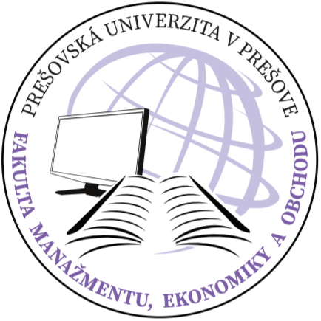
UNIVERSITY OF PREŠOV IN PREŠOV
FACULTY OF MANAGEMENT AND BUSINESS
Konštantínova 16, 080 01 Prešov, Slovakia

An Individual Study Plan of a PhD Candidate

Name:.........................Surname:..............................Née:.......................Degree :........

Date of birth:............................in:...............Personal identification number: ...............

Permanent address:...............................................................................................................

Field of study:................................................................................................................

Study programme:.........................................................................................................

Supervisor:.....................................................................................................................

Form of study:................................................................................................................

The theme of the dissertation thesis:.............................................................................................................................
........................................................................................................................................

The beginning of doctoral study: ...................................................

Scheduled completion of doctoral study: ................................................................

The individual study plan approved and submitted (date) ...........................................

PhD Candidate:.............................................................................................................

Supervisor:..................................................................................................................

Chairman of the Field Committee:................................................................................

Dean:............................................................................................................................

Planned units of the doctoral study programme:

Planned units of study and pedagogical activities:

Unit | Completion | Year of study | Number of credits
Compulsory subjects
Compulsory optional subjects

Planned units of creative activities in the field of science

Unit | Completion | Year of study | Number of credits

A doctoral examination:

A scheduled date of the doctoral examination: .........................................................................

The list of the subjects for the doctoral examination chosen from the list approved by the Field Committee:

....................................................... .......................................................

....................................................... .......................................................

....................................................... .......................................................

....................................................... .......................................................

....................................................... .......................................................

....................................................... .......................................................

The list of compulsory and recommended literature to be studied by a PhD candidate within their individual preparation for the doctoral examination:

A dissertation thesis:

The plan for writing a dissertation thesis:

Task | Deadline

Preparation guidelines for the individual study plan of a PhD candidate

In accordance with § 54 of Act No. 131/2002 Coll. on Higher Education and on Changes and Amendments to Certain Laws as amended as well as with the Study Rules and Regulations of the University of Prešov, a doctoral study programme consists of two parts – a study and research part. It is run in compliance with the accredited study programme.

The supervisor works out the individual study plan for each student. This has to be submitted to the Field Committee for the approval. The individual study plan has two parts: a study and a research part. The study part ends with the doctoral examination and the research part with the defence of the dissertation thesis.
The individual study plan of a PhD candidate is to be proposed and submitted using a document entitled An Individual Study Plan of a PhD Candidate.

The individual study plan consists of:
- The list of the units of study and pedagogical activities (compulsory, compulsory optional or optional according to the accredited study programme) with deadlines, formal end of the subject and a number of credits to be obtained in a given academic year. The required number of credits is given by the accredited study programme as well as by the paragraph 27 of the Study Rules and Regulations of the University of Prešov in Prešov.
- The list of the units of creative activities in the field of science with their credits requirements.
- The list of subjects for a doctoral examination chosen from the list approved by the Field Committee.
- The list of literature to be studied by the PhD student within their individual preparation for a doctoral examination.
- A theme of a dissertation thesis (which can be specified or modified only with the approval of the chairman of the Field Committee and the Dean at the end-of-the-year evaluation of the PhD student).
- A plan for writing the dissertation thesis.

The individual study plan has to be approved and signed by a PhD student, Supervisor, Chairman of the Field Committee and the Dean of the faculty. The individual study plan signed by a PhD student and a supervisor is to be submitted to the Department of Science and Doctoral Studies at the enrolment.

Moreover, the report of doctoral study (index) is issued to internal as well as external PhD students (in accordance with § 67 of Act No. 131) including the same information as the individual study plan: the units of study and pedagogical activities and the units of creative activity in the field of science with deadlines, a formal end of subject and a number of credits required in a given academic year.

In case of any questions or comments, please feel free to contact the Department of Science and Doctoral Studies at the Faculty of Management, University of Prešov in Prešov.

Associate Professor Richard Fedorko, PhD. Professor Róbert Štefko, Ph.D. Vice-Dean for Science and Research and Doctoral Study Dean

