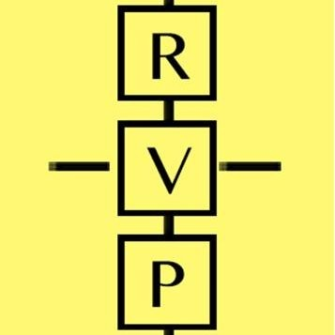
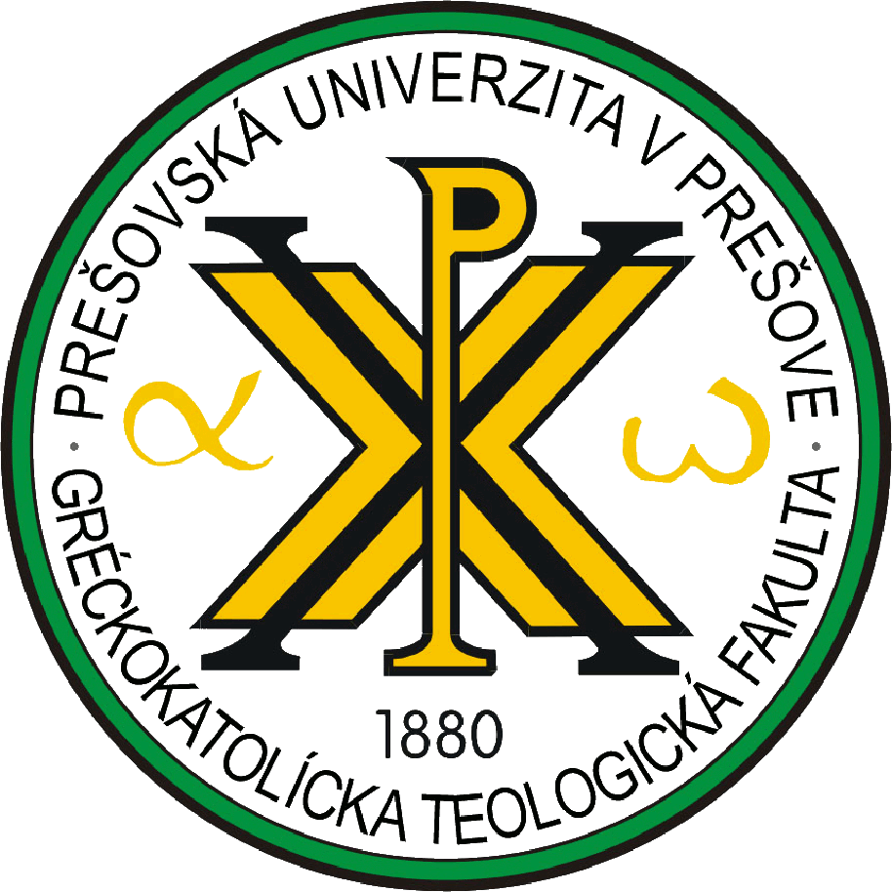
International Conference
Intercultural Dialogue and the Transformation of Borders
June 9-11, 2023 Building of the Greek-Catholic theological faculty University of Prešov, Slovakia
June 9, 2023 (Friday)
Time | Agenda
 | Opening Session
09.00-09:30 | Gabriel Paľa  First Vice-Rector of the University of Prešov  Mons. Peter Rusnák  Apostolic Administrator  Mons. Peter Šturák  Dean of the Greek-Catholic Theological Faculty  Pavol Dancák  Head of Department of Philosophy and Religious Studies, Greek-Catholic Theological Faculty, University of Prešov  William A. Barbieri  Director of the McLean Center for the Study of Culture and Values, the Catholic University of America, Washington DC
 | Session I Borders and Boundaries
09:30-11:00 | Moderator | Speaker／Topic
09:30-11:00 | Leszek Korporowicz | João J. Vila-Chã: Understanding Borders and Boundaries in Our Times
09:30-11:00 | Leszek Korporowicz | Władysław Zuziak: What It Means to be European: On the Benefits of Diversity
09:30-11:00 | Leszek Korporowicz | Krzysztof Wielecki: Boundaries That Emerge beyond Borders
11:00-11:30 | Coffee/Tea Break
 | Session II Social Challenges and the Other
11:30-12:30 | Moderator | Speaker／Topic
11:30-12:30 | Michal Valčo | Radoslav Lojan: Nicolae Steinhardt and His Concept of Social Order
11:30-12:30 | Michal Valčo | Krzysztof Mech: Hermeneutics of the Other: Triple Challenge
12:30-14:00 | Lunch
 | Session III Cultural Diversity and Religious Heritages
14:00-15:30 | Moderator | Speaker／Topic
14:00-15:30 | Radoslav Lojan | Ioan Dura: Reconstructing the Architecture of Religious Diversity: The Significance of Borders in Contemporary Society
14:00-15:30 | Radoslav Lojan | Adam Żaliński: Participatory Heritage and Heritage without Heirs: Values, Community Formation, and Engagement in Preservation of Religious Sites
14:00-15:30 | Radoslav Lojan | Sylwia Jaskuła-Korporowicz and Leszek Korporowicz: Communicating Heritage: Crossing Cultural Borders
15:30-16:00 | Coffee/Tea Break
 | Session IV Central European Experience
16:00-17:00 | Moderator | Speaker／Topic
16:00-17:00 | João J. Vila-Chã | Katarína Valčová: Critical Assessment of the Concept “Panorthosia” as Possible and Effective Principle for Intercultural Dialogue
16:00-17:00 | João J. Vila-Chã | Abp Cyril Vasiľ: The Greek Catholic Church among Changing Borders and Cultures in Central Europe.
17.00-19.00 | Visit: The Greek Catholic Cathedral and The Archbishop’s Residence
19.00-21.00 | Dinner

June 10, 2023 (Saturday)
Time | Agenda
 | Session I Intercultural and Interreligious Dialogue
09:30-11:00 | Moderator | Speaker／Topic
09:30-11:00 | Ioan Dura | Michal Valčo: The Transhumanist Challenge to Intercultural Dialogue
09:30-11:00 | Ioan Dura | Marcel Mojzeš: Theology of Incarnation as a Christian Basis for the Intercultural Dialogue and the Transformation of Borders
09:30-11:00 | Ioan Dura | Maria Kardis and Kamil Kardis: The Amoral Archetype of the 'Eternal Child' by Michel Maffesoli in the Perspective of Cultural Change in Central Europe
11:00-11:30 | Coffee/Tea Break
 | Session II Education and Justice
11:30-12:30 | Moderator | Speaker／Topic
11:30-12:30 | Marcel Mojzeš | Marek Rembierz: Transformations of the Intercultural Education: Pedagogical Explorations on the Borderlands
11:30-12:30 | Marcel Mojzeš | William Barbieri: Constitutive Justice and the Transformation of Boundaries
12:30-14:00 | Lunch
 | Session III Cultural and Religious Diversities across Borders
14:00-15:30 | Moderator | Speaker／Topic
14:00-15:30 | Katarína Valčová | Pavol Dancák: Contemporary People from Hideouts and the Problem of Border Transformation
14:00-15:30 | Katarína Valčová | Daniel Slivka: Multicultural Diversity Forensic Research and Analysis in Slovakia
14:00-15:30 | Katarína Valčová | Sandra Zákutná and Rudolf Dupkala: Inter-Cultural and Inter-Religious Dialogue in the Contexts of Axiological Pluralism (An Emphasis on the Dialogue of Christianity with Judaism and Islam)
15:30-16:00 | Coffee/Tea Break
 | Session IV Asian Experiences
16:00-17:00 | Moderator | Speaker／Topic
16:00-17:00 | Pavol Dancák | Do Thi Kim Hoa: Transformations in Vietnam’s Traditional Village Culture Amidst Global Integration
16:00-17:00 | Pavol Dancák | Hu Yeping: Integration of Cultures: An Asian Experience
17.00-17.15 | Concluding Session
17.30-19.00 | Visit: The Salt Mining Museum and The Roman Catholic Cathedral
19.00-21.00 | Dinner

June 11, 2023 (Sunday)
Time | Agenda
9.00-18.30 | Visit: The High Tatras and Levoča
18.30-20.30 | Dinner

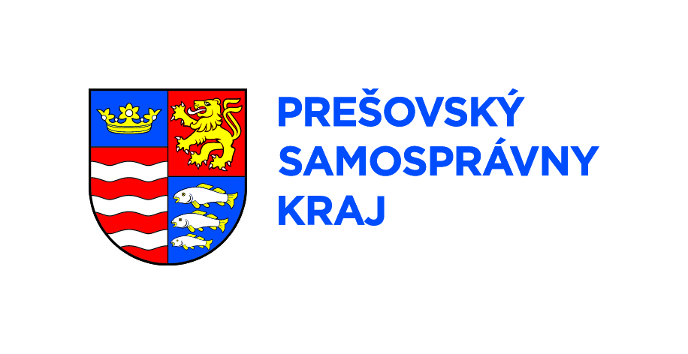
Conference Partner: Prešovský samosprávny kraj

