 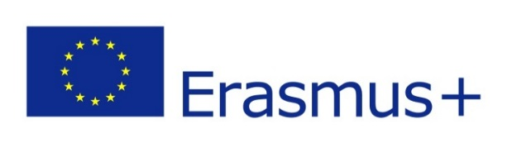

**Summer 2016: Time to Learn and Time to Grow**

**Erasmus+ Student Placements at Varna University of Management**

**Dear Erasmus+ university partner**,

We at Varna University of Management (VUM) are pleased to announce that starting this summer VUM will offer a series of student placement opportunities to students of our partner universities.

We are looking for enthusiastic, open-minded, talented and interested students who are eager to learn and grow in a diverse multicultural environment. In summer 2016 we will provide various student placement opportunities in the following VUM departments:

* International Cooperation
* Student Admission and Recruitment
* Facility Management and Logistics.

Through an Erasmus+ placement in these departments, students of our partner universities will benefit from a dynamic multicultural environment and numerous opportunities to gain hands-on experience and relevant knowledge of office routine. They will have access to VUM international student community and will work with our international students on a daily basis. Students involved in an Erasmus+ summer placement at VUM will be also offered the opportunity to attend courses free of charge provided in the framework of VUM Summer School. It shall be noted here that in summer 2016 students from more than 20 countries will attend our Summer School.

**Eligible students’ profile**

We expect to receive applications from students who study on the undergraduate or master level in any of the listed fields, namely business, management, administration, tourism, event management, information systems, and information technologies. Applicants shall have at least B1 level of English proficiency and shall be motivated to learn and grow.

**Costs of living**

Costs of living in Bulgaria are more than affordable and students are expected to cover these in the framework of an Erasmus+ student mobility grant for placement. Further information about the living expenses at Bulgaria could be found [here](http://vum.bg/expenses/).

**Application deadline**

Students shall send us their CV no later than **19th March 2016**. We will conduct skype interviews with all applicants and will announce the selection results on 1st April.

**Student placement duration**

Student placements at VUM shall have duration of minimum 2.5 months and shall take place between 15th May and 30th September 2016. Selected students will be expected to contribute to work in one of the above listed VUM departments with duration of 20 hours per week. An experienced tutor will be assigned to each of the selected students.

Should you have any questions on the student placement opportunities at VUM, please, do not hesitate to contact me at [christina.armutlieva@vumk.eu](mailto:christina.armutlieva@vumk.eu).

We look forward to welcoming your students at VUM this summer.

Yours truly,

Christina Armutlieva

Director of International Cooperation

Varna University of Management