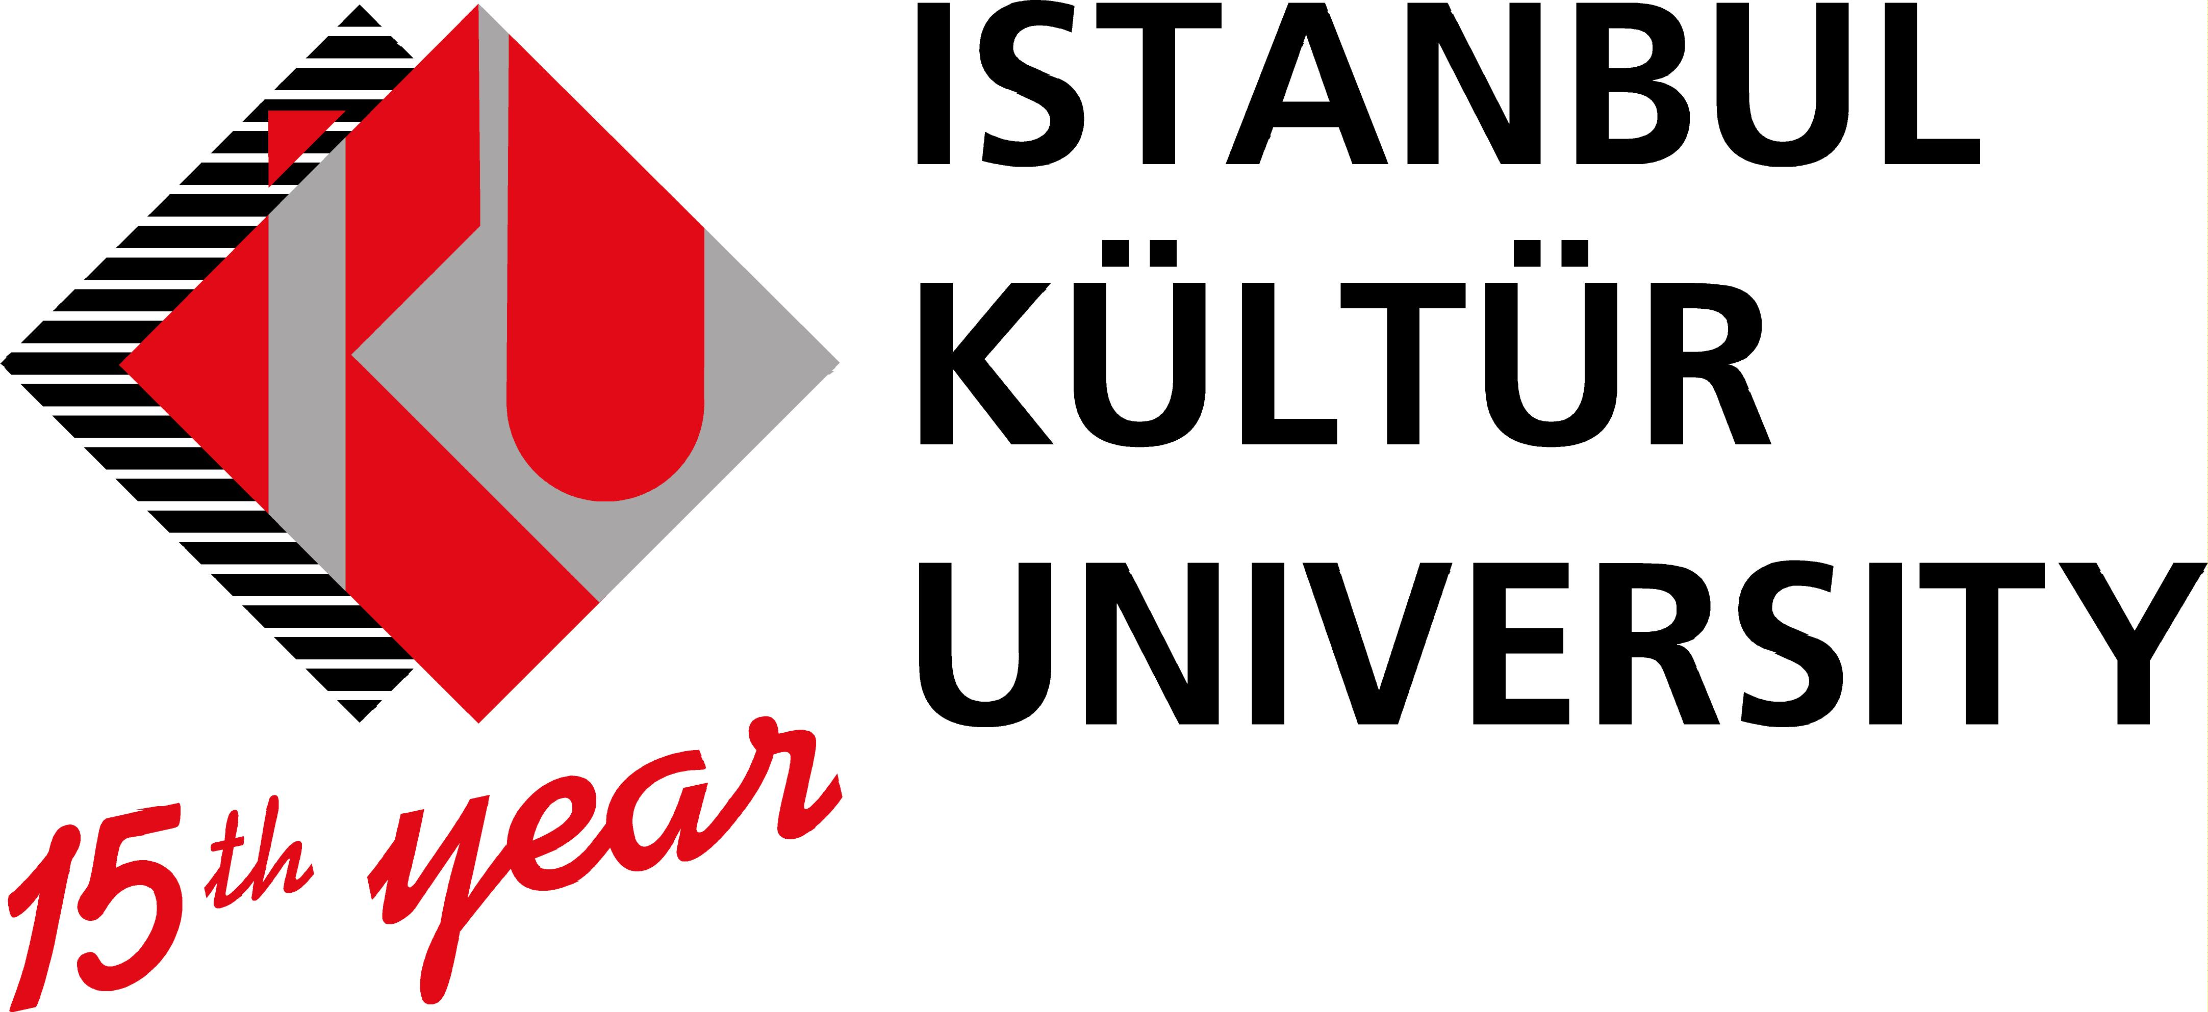
Placement Offer Form
EMPLOYER INFORMATION
Name of organization | ISTANBUL KÜLTÜR UNIVERSITY
Address | European and International Center, Atakoy Campus, Floor: 5, Bakırkoy
Postal Code | 34156
City | ISTANBUL
Country | TURKEY
Telephone | +90 212 498 41 68
Fax | +90 212 498 41 88
E-mail | eic@iku.edu.tr
Website | www.iku.edu.tr
Number of employees | app. 900
Year of foundation | 1997
Contact person | Zeliha Akın
Department / Function | European and International Center
Direct telephone number | +90 212 498 41 68
Direct mobile
Direct e-mail address | z.akin@iku.edu.tr
Short Description of the Company | Istanbul Kültür University is a foundation university founded as public corporation. Since its foundation in 1997, Istanbul Kültür University has been dedicated to play a constructive role in the formation of a transnational European education space through spreading scientific knowledge about European integration and facilitating intercultural encounters. This involves institutional awareness and support of the Lisbon Strategy as well as the Bologna Process.  Academic education and research at IKU is conducted through 22 programs in 6 faculties, 18 programs in 3 vocational high schools, as well as 41 Graduate Programs and 4 PhD Programs at 2 institutes. In total, 7708 students are enrolled in those programs.  Since 2004, within the scope of Erasmus Student Work Placement, 41 students from IKU successfully completed their internships at the companies/institutions located in the European Union member states and IKU received 7 Erasmus Student Work Placement students from different European universities.

PLACEMENT INFORMATION
Department / Function | Foreign Policy Platform
Description of activities | (See enclosed). Enclosed is a description of activities of The Platform, which the intern expected to take part and to serve;  Foreign Policy Platform (FPP) of Istanbul Kültür University has been established in May 2006, to perform the duties of a research center for international studies and serve as a think-tank of the University and to establish links of cooperation with national and international organizations operating in the same field.  Since its foundation, it has established links with many foreign institutions in various countries and institutionalized cooperation and exchange programs with partner organizations. Thus numerous joint activities have been materialized with a variety of international partners.  Some of the local and international activities so far organized are brain-storming sessions, ambassadorial conferences, foreign guests speakers, symposia, workshops, seminars, some of which have been jointly organized with foreign institutions, during the course of its active life of approximately two and a half years.  Among the foreign institutions with which the FPP has had cooperated, some of which have been institutionalized relationships are the GCSP (Geneva Center for Security Policies) in Switzerland, CEP (Center for European Perspective) in Ljubljana Slovenia (Amb. Ret. Murat Bilhan, Chariman of FPP is also a member of the Advisory Board of CEP); RNSSC (Regional Network of Strategic Studies Centers); NESA (Near East and South Asia), a branch of Washington Defence University; strategic studies centers of 16 countries affiliated with the RNSSC; BCN (Balkan Communication Network) 29 centers of strategic research from 9 Balkan countries; many other academic and strategic centers from Russia, Japan, Australia, New Zelland, China, United Arab Emirates and GRC (Gulf Research Center), Qatar, Saudi Arabia, Egypt, TRNC (Turkish Republic of Northern Cyprus), Greece, Germany, Italy, Iran Sub-Saharan Africa (including the African Union, regional African organizations and some countries mainly in East Africa); Central Asian countries.  The intern is expected to help in communication and correspondence with other institutions; filing and archiving of documents; finding references for article writing and further research; participating and helping in the activities in and out of the University.
Duration | Min. 3 months – max. 12 months
Working hours / Weekly hours | 6 hours per day / 5 days per week
City | ISTANBUL
Help with finding Accommodation | Yes  No
Financial Contribution | Yes  No
Other | Lunch will be provided

REQIUREMENTS
Oral and written language skills | English (level: Advanced)  German (level: )  Other (level: )
Computer skills | General computer skills (Windows, Internet, Office 2010)
Drivers license | Yes  No
Other

