|  |
| --- |
|  |
| CONSEJERÍA DE EDUCACIÓN,  CULTURA Y DEPORTES C.E.I.P. Valsequillo C.I. Nº 35004683  C/ Maestro de José Santana E. Nº 4  TFno. Fax: 928705230  35217 - Valsequillo |

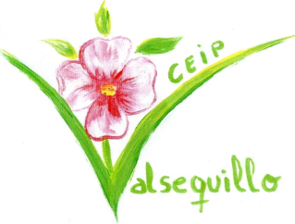

Valsequillo, 19 February 2013

Valsequillo School is a State Primary School located in Valsequillo, a small village in Gran Canaria, one of the seven Canary Islands in Spain.

CEIP Valsequillo educational community recognizes the importance of contact with speakers of other European languages. Learning a foreign language is a necessity in the context in which we live, as our island inhabitants live mainly from tourism.  
Our center is located in the middle of the island and many of our families work in the tourist area outside.

Since we have this situation and besides our students do not have opportunities to practise the language in our village, we have a need to encourage the learning of another language ensuring that our students complete their training and basic skills development to find a job in a near future, either in our island or anywhere in the European Union territory.  
 We would like to improve the acquisition of a 2nd language and motivate our students with the presence of a person to communicate with. Therefore, this is the main reason to apply for a language assistant. Furthermore, in our education, one of our aims is promoting the integration of people from other countries and cultures. Last year we debuted in Schoolvision and won a prestigious third position. You can watch our video here: <http://schoolovision2012.blogspot.de/2012/05/spain-vivo-en-un-archipielago-i-live-in.html>

We are looking for an Erasmus student who will give our pupils the possibility to meet people from all around the world, getting to know other cultures, and helping them being more open-minded. In return, Erasmus student will be offered the chance to learn about local traditions and to get to know Canarian people, who are well known for being friendly and easy-going.

As a school, we are proud of participating in the CLIL project where every child develops a positive attitude towards learning, diversity and cooperation.

Our main aims are to achieve the following:

* A natural classroom learning environment.
* Students involved in their own learning.
* Positive relationships and interactions.
* The increase use of information communication technologies (ICT) tools for teaching and learning.

Join us! You will be welcome to our school family!

Elvira Vaquero Rodríguez, the headmistress