ΗELLENIC REPUBLIC
MINISTRY OF EDUCATION AND RELIGIOUS AFFAIRS, CULTURE AND SPORTS
------
STATE SCHOLARSHIPS FOUNDATION
(Ι.Κ.Υ.)
DIRECTORATE FOR SPECIAL PROGRAMMES
AND INTERNATIONAL SCHOLARSHIPS
UNIT FOR EUROPEAN UNION PROGRAMMES
------



ERASMUS Placement Offer Form

EMPLOYER INFORMATION
Name of Organization | CELL OF ALTERNATIVE YOUTH ACTIVITIES
Address | PATROKLOU 57
Postal Code | 13122
City | ILION, ATHENS
Country | GREECE
Telephone | 0030 210 2692881
Fax | 0030 210 2692880
e-mail | info@kean.gr
Website | www.kean.gr
Number of Employees | 6
Year of Foundation | 2005
Contact Person | SOTIRIA LOUKA
Department/Function | OFFICE MANAGER
Direct Telephone Number | 0030 210 2692880
Direct Mobile | 0030 6986145501
Direct e-mail address | hrwlkkean@gmail.com
Short Description of the Company  (Please attach profile of your company, max 1 page) | Philosophy  KEAN is an inclusive youth society. The organization’s main goal is to pursue activities leading to the improvement of the quality of life focusing on the protection of the environment including the promotion of new technologies, youth education and youth rights. In KEAN we strongly believe that quality of life presupposes the existence of a healthy participatory democratic society. As such KEAN devotes special attention to include activities that support social minorities and disadvantaged social groups in their fights against discrimination, racism and violence. In short we understand the promotion of ‘quality of life’ as a broader issue, which includes the protection of the environment, an informed youth with strong education and a participatory society.  KEAN works like a cell; like the cell that breaks and multiplies KEAN creates new ‘Cells’ that equally inspire one another. Every ‘cell’- branch is a separate entity, within the frame of the organization. It raises issues that preoccupy its members and communicates them to the other ’Cells’. It realizes activities and can receive support from all of KEAN’s members. As such it builds its own agenda on local issues while following and participating to the universal thematic topics decided by the organization. Each ‘Cells’ goal is to function independently and autonomously with several degrees of freedom on the local issues while mobilizing for the broader ones.  Approaches and methods  To succeed in our goals, our strategy is to pursue a range of activities using a variety of methods while placing the highest possible degree of creativity and innovation. In KEAN we believe that we can only be effective by focusing on more than one type of activity and thematic field. Moreover, we understood early on that each geographical area and each different youth-group, has its own priorities and needs to which, we try to respond. As such our recent activities include the organization of a Mediterranean conference on the “Environment and New technologies”, the production of a multi-tasking table-game called “Planetbook” which raises awareness on ecological issues as well as promoting the activities of environmental NGOs, the issuing of a monthly newspaper devoted to environmental and cultural questions that concern local societies and the organization of several competitions for youth and activities such as reforestation, visits in natural sites and NGO networking events.. Since our establishment, we have also been trying to broaden our geographical reach outside our headquarters in Athens, and when possible, outside Greece. That is why, today, we have local active offices in eight other areas of Greece and we have organized several seminars and actions with participants from Greece and Europe.  To reach its goals ΚΕΑΝ has established partnerships with many similar international societies and clubs that are inspired by the same values and goals. However, today we wish to become even more active in cooperation with organizations in our immediate neighborhood. That is countries from the region of the Mediterranean and the Balkans. We aim to cooperate with organizations with an established record of activities, whether these are large or smaller ones. Moreover, we are open at cooperating with local authorities – which we have done so in several instances in the past – in order to increase the level of penetration to local audiences.
Other

PLACEMENT INFORMATION
Number of positions offered for student placement | 2
In the Department/Function (where the position is offered) | EUROPEAN PROJECTS MANAGEMENT /  COMMUNICATION AND INTERNATIONAL RELATIONS
Description of activities the student will be involved in | Administrative tasks for the development, management and support of European projects / management and development of European network, dissemination, management of international website, creation of promotional material.
Duration | 6 months to 12 months
Working Hours/Weekly Hours | 40h / week
City | ATHENS
Help with finding  Accommodation | - Yes  No
Financial Contribution | Yes €  - No
Other
REQUIREMENTS
Study Field | (Please choose a field/s from Table A: pages 3, 4, 5 & 6 of this form)
Oral and Written Language Skills | Greek (level: )  - English (level: C2 )  French (level: )  German (level: )  Other (level: )
Computer Skills | REQUIRED
Drivers license | Yes  - No
Other

Should you have any questions, please do not hesitate to contact us
(E-mail: elinamav@iky.gr, tel. 210-3726388)

Place ATHENS, Date 08/02/2013

Signature
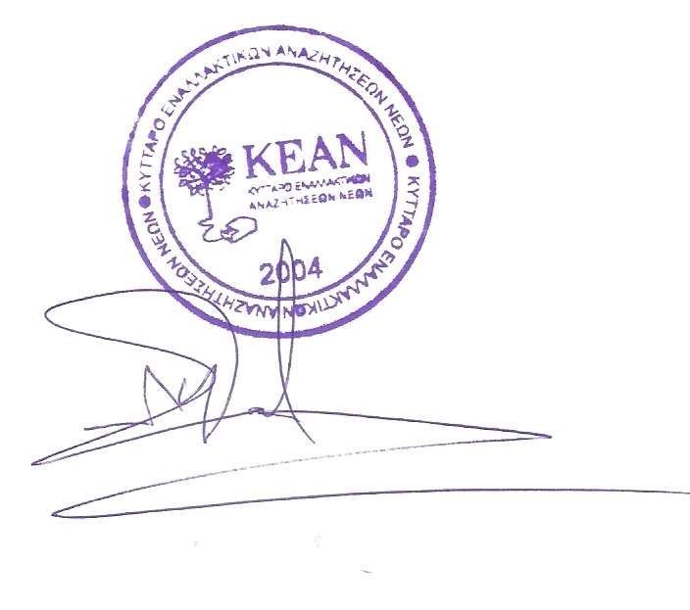

Please return this form by e-mail to the Hellenic LLP National Agency/IKY: elinamav@iky.gr

Table A - Fields of Education & Training

X | Description
 | General Programmes
 | Basic/broad, general programmes
 | Basic/broad, general programmes
 | Literacy and numeracy
 | Literacy and numeracy
 | Personal skills
 | Personal skills
 | Education
 | Teacher training and education science
X | Teacher training and education science (broad programmes)
X | Teaching and training
 | Education science
 | Training for pre-school teachers
 | Training for teachers at basic levels
 | Training for teachers with subject specialisation
X | Training for teachers of vocational subjects
 | Teacher training and education science (others)
 | Humanities and Arts
 | Arts
 | Arts (broad programmes)
 | Fine arts
 | Music and performing arts
 | Audio-visual techniques and media production
 | Design
 | Craft skills
 | Arts (others)
 | Humanities
 | Humanities (broad programmes)
 | Religion
 | Foreign languages
 | Mother tongue
 | History and archaeology
 | Philosophy and ethics
 | Humanities (others)
 | Social sciences, Business and Law
 | Social and behavioural science
 | Social and behavioural science (broad programmes)
 | Psychology
 | Sociology and cultural studies
 | Political science and civics
 | Economics
 | Social and behavioural science (others)
 | Journalism and information
 | Journalism and reporting
 | Library, information, archive
 | Journalism and information (others)
 | Business and administration
 | Business and administration (broad programmes)
 | Wholesale and retail sales
 | Marketing and advertising
 | Finance, banking, insurance
 | Accounting and taxation
 | Management and administration
 | Secretarial and office work
 | Working life
 | Business and administration (others)
 | Law
 | Law
 | Science, Mathematics and Computing
 | Life science
 | Biology and biochemistry
 | Environmental science
 | Life science (others)
 | Physical science
 | Physical science (broad programmes)
 | Physics
 | Chemistry
 | Earth science
 | Physical science (others)
 | Mathematics and statistics
 | Mathematics
 | Statistics
 | Mathematics (others)
 | Computing
 | Computer science
 | Computer use
 | Computing (others)
 | Engineering, Manufacturing and Construction
 | Engineering and engineering trades
 | Engineering and engineering trades (broad programmes)
 | Mechanics and metal work
 | Electricity and energy
 | Electronics and automation
 | Chemical and process
 | Motor vehicles, ships and aircraft
 | Engineering and engineering trades (others)
 | Manufacturing and processing
 | Manufacturing and processing (broad programmes)
 | Food processing
 | Textiles, clothes, footwear, leather
 | Materials (wood, paper, plastic, glass)
 | Mining and extraction
 | Manufacturing and processing (other)
 | Architecture and building
 | Architecture and town planning
 | Building and civil engineering
 | Architecture and building (others)
 | Agriculture and Veterinary
 | Agriculture, forestry and fishery
 | Agriculture, forestry and fishery (broad programmes)
 | Crop and livestock production
 | Horticulture
 | Forestry
 | Fisheries
 | Agriculture, forestry and fishery (others)
 | Veterinary
 | Veterinary
 | Health and Welfare
 | Health
 | Health (broad programmes)
 | Medicine
 | Nursing and caring
 | Dental studies
 | Medical diagnostic and treatment technology
 | Therapy and rehabilitation
 | Pharmacy
 | Health (others)
 | Social services
 | Child care and youth services
 | Social work and counselling
 | Social services (others)
 | Services
 | Personal services
 | Personal services (broad programmes)
 | Hotel, restaurant and catering
 | Travel, tourism and leisure
 | Sports
 | Domestic services
 | Hair and beauty services
 | Personal services (others)
 | Transport services
 | Transport services
 | Environmental protection
X | Environmental protection (broad programmes)
 | Environmental protection technology
 | Natural environments and wildlife
 | Community sanitation services
X | Environmental protection (others)
 | Security services
 | Security services (broad programmes)
 | Protection of persons and property
 | Occupational health and safety
 | Military and defence
 | Security services (others)
 | Other (please list)

