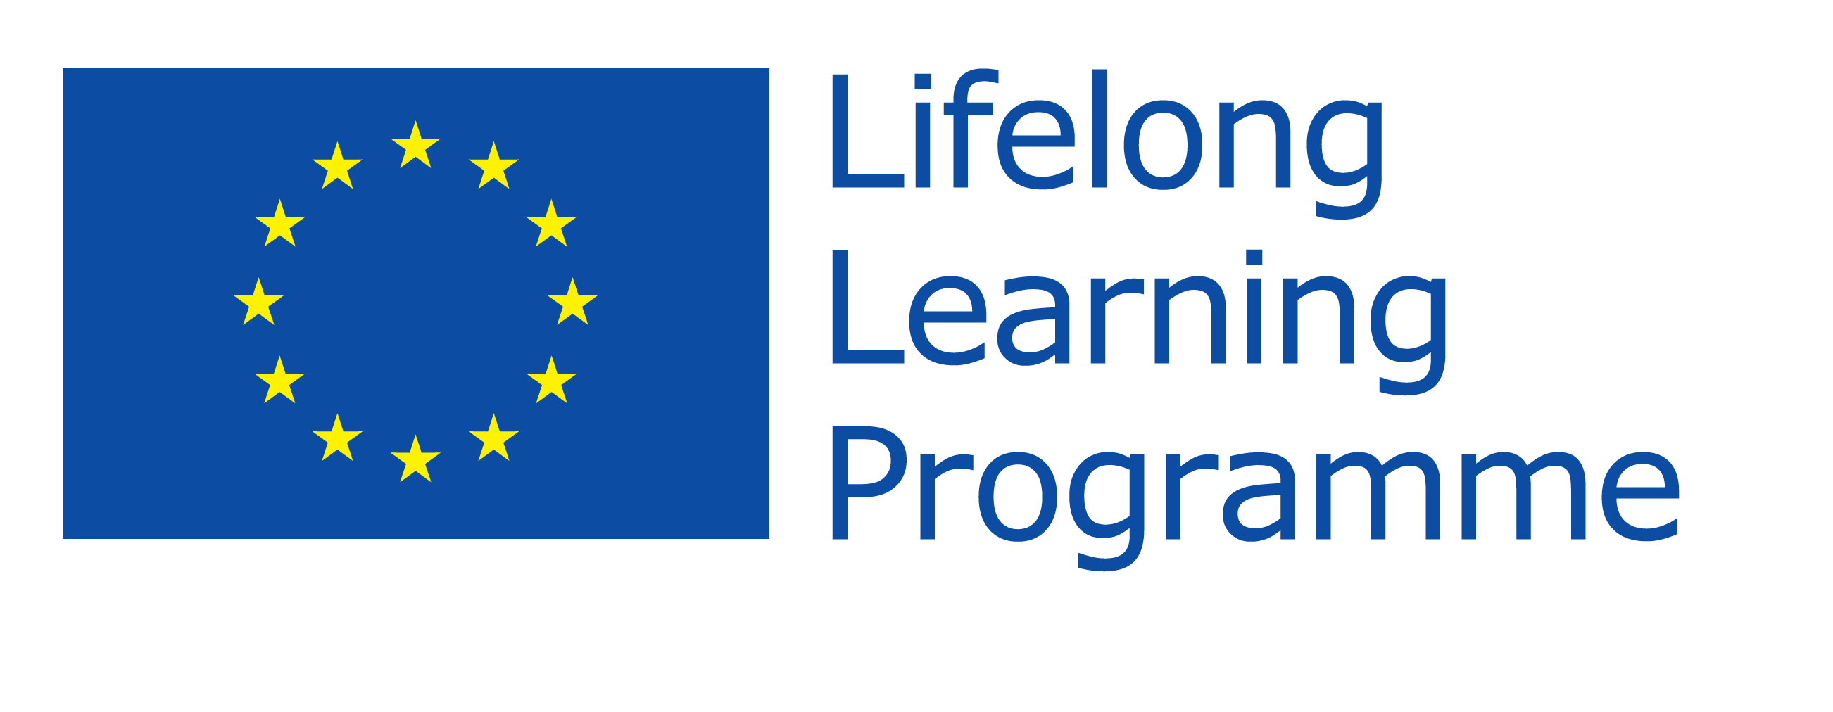
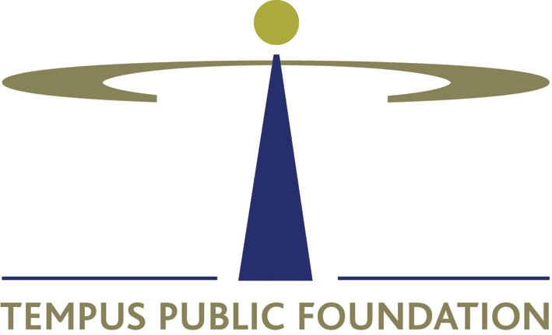
ERASMUS PLACEMENT OFFER
EMPLOYER INFORMATION
NAME OF ORGANISATION | NORDTEK IMEXCO Kft.
ADDRESS | Szőnyi street 21/a
POSTAL CODE | H-1142
CITY | Budapest
COUNTRY | Hungary
TELEPHONE | +36 1 363 1447, +36 1 256 1952
FAX | +36 1 363 06 66
E-MAIL | lucia.gertliova@allinpackaging.eu
WEBSITE | http://allinpackaging.co.uk/
NUMBER OF EMPLOYEES | 30
SHORT DESCRIPTION OF THE COMPANY | Nordtek IMEXCO Kft. is multinational company which brings packaging solutions to its customers over 20 years. We stand on strong tradition of high quality service for our customers and partners and at the same time we are developing new ways to reach our clients.
OTHER | We are operating an online international sales platform for our industry which connects packaging buyers and suppliers throughout Europe and the world.

CONTACT DETAILS
CONTACT PERSON | Lucia Gertliova
DEPARTMENT / FUNCTION | Marketing & HR assistant
DIRECT TELEPHONE NUMBER | +36 1 363 14 47 / 14
E-MAIL | lucia.gertliova@allinpackaging.eu
OTHER

PLACEMENT INFORMATION
DEPARTMENT / FUNCTION | International Online Marketing & Sales internship  (Marketing department)
DESCRIPTION OF ACTIVITIES  AND TASKS | The intern has to do a market research about his/her own country on the field of packaging and the possible partnerships. The intern has to be aware of the online market in his/her own country.  From the above mentioned information the intern has to create an output which is relevant for the Hungarian local market.  The intern has to create and carry out the local marketing strategy for the company.  The intern has to explore the potential partnerships with online websites and platforms in order to promote the company.  The intern has to create and design the promotion and marketing materials for the target markets.
LOCATION | Budapest, Hungary
START DATE | ASAP or throughout the year
DURATION | 3-12 months
WORKING HOURS PER WEEK | 40
HELP WITH FINDING ACCOMMODATION | possible assistance
PAYMENT OR OTHER BENEFITS | young dynamic work team, professional assistance
OTHER | Because we like innovative ways to do our business we cooperate with student trainees and give them opportunity to bring their own ideas and implement them into our marketing strategy.  With Nordtek, you will have a chance to develop in professional area and gain the professional work experience that will help you to find a permanent job after your studies.  We are constantly looking for interns from European countries to support our business development in their respective countries.  The positions involve both marketing and sales related tasks and offer great opportunity to gain experience. We offer great freedom in planning and executing the local strategies and give constant professional support.

REQUIREMENTS
REQUESTED PROFILE OF THE ERASMUS STUDENT (fields of studies, completed years of studies, other professional requirements) | student in field of any: marketing, advertising, promotion, PR, business or sales
ORAL AND WRITTEN LANGUAGE SKILLS AND LEVEL OF SKILLS REQUIRED | Native speaker of at least one of these languages + English:  Chinese  Croatian  Czech  Danish  Dutch  English  Finnish  French  German  Greek  Hebrew  Italian  Norwegian  Polish  Portuguese  Russian  Serbian  Slovak  Slovenian  Spanish  Swedish  Ukrainian
COMPUTER SKILLS AND LEVEL OF SKILLS REQUIRED | Required skills:  PC User Skills  Internet User Skills  Marketing / Selling skills  Preferred skills:  SAP  Photoshop  HTML  PHP
DRIVER’S LICENSE | not required
OTHER

Other
APPLICATION DEADLINE
REQUIRED DOCUMENTS (CV, motivation letter, etc.) | CV, cover letter
HOW TO APPLY? | Send your CV and short cover letter to Lucia.Gertliova@gmail.com and we will contact you back shortly. In the subject please type Int. Online Marketing & Sales Internship
Please return this form by email to erasmusplacement@tpf.hu

