SAMPLE PAGES AND EXAMPLES
FOR DISSERTATIONS AND THESES
Compiled in accordance with the Slovak Ministry of Education, Science, Research
and Sport Decree No 233/2011 of 1 July 2011,
as amended

Note:
Explanatory notes are given in blue.

UNIVERSITY OF PRESOV IN PRESOV
FACULTY OF MANAGEMENT AND BUSINESS

TITLE OF THESIS

Dissertation thesis

2025
Name, Surname + titles/ Mgr. Peter Novák
UNIVERSITY OF PRESOV IN PRESOV
FACULTY OF MANAGEMENT AND BUSINESS

TITLE OF DISSERTATION THESIS
subtitle of thesis

Dissertation thesis

Study programme: Management
Field of study: Economics and Management
Supervising workplace: …….
Supervisor: ……..

Prešov 2025
Name, Surname + titles/ Mgr. Peter Novák

Declaration

I hereby solemnly declare that I have compiled my dissertation/thesis independently, based on my own knowledge, using the information sources specified in the list of bibliographical references.
I declare that I have not used artificial intelligence tools. / I declare that I have used AI tools in accordance with relevant legislation, academic rights and freedoms, ethical and moral principles while maintaining academic integrity and that their use is appropriately indicated in the thesis.

Prešov DD.MM.YYYY ......................................................

ABSTRAKT
NOVÁK, Peter. Možnosti využitia multimediálnych pomôcok vo vyučovaní anglického jazyka [dizertačná práca]. Prešovská univerzita v Prešove (Prešov, Slovensko). Fakulta manažmentu, ekonomiky a obchodu. Katedra interkultúrnej komunikácie. Školiteľ: doc. Mgr. Eva Benková, PhD. Stupeň odbornej kvalifikácie: doktor. Prešov: FMEO PU, 2012. 44 s. → Example of abstract title

Text text text text text text text text text text text text text text text text text text text text text text text text text text text text text text text text text text text text text text text text text text text text text text text text text text text text text text text text text text text text text text text text text text text text text text text text text text text text text text text text text text text text text text text text text text text text text text text text text text text text text text text text text text text text text text text text text text text text text text text text text text text text text text text text text text text text text text text text text text text text text text text text text text text text text text text text text text text text text text text text text text text text text text text text text text text text text text text text text text text text text text text text text text text text text text text text text text text text text text text text text.

Kľúčové slová: Slovo. Slovné spojenie. Slovo. Slovné spojenie. Slovo. Slovné spojenie.

Slovo. Slovné spojenie. Slovo. Slovné spojenie. Slovo. Slovné spojenie.

The abstract contains information on the aims of the dissertation/thesis and a brief summary of the contents. The conclusion of the abstract addresses the fulfilment of the Ames, the methods used and the results and conclusions of the dissertation/thesis. The contents and form of the abstract are governed by international standard STN ISO 214: 1998, Abstract Documentation for Publications and Documentation. The abstract should generally be between 100 and 500 words, written as one continuous paragraph, and must be in Slovak and English. The supervisor of the dissertation/thesis may also stipulate other language versions for the abstract. Each language version must be on a separate page. The abstract must also include three to five keywords.
ABSTRACT
NOVÁK, Peter. Possibilities of Using Multimedia Aids in Teaching English Language [dissertation thesis]. University of Prešov (Prešov, Slovakia). Faculty of Management and Business. Department of Intercultural Communication. Supervisor: doc. Mgr. Eva Benková, PhD. Degree of qualification: Philosophiae doctor [PhD.]. Prešov: FMB, UP, 2012. 54 p.

Text text text text text text text text text text text text text text text text text text text text text text text text text text text text text text text text text text text text text text text text text text text text text text text text text text text text text text text text text text text text text text text text text text text text text text text text text text text text text text text text text text text text text text text text text text text text text text text text text text text text text text text text text text text text text text text text text text text text text text text text text text text text text text text text text text text text text text text text text text text text text text text text text text text text text text text text text text text text text text text text text text text text text text text text text text text text text text text text text text text text text text text text text text text text text text text text text text text text text text text text text

Keywords:
Word (Word. Phrase). Word (Word. Phrase). Word (Word. Phrase). Word (Word. Phrase). Word (Word. Phrase).

CONTENTS
LIST OF FIGURES AND LIST OF TABLES 6
LIST OF ABBREVIATIONS AND SYMBOLS 7
INTRODUCTION 8
1 HEADING 9
1.1 Subheading 9
1.1.1 Subheading 9
1.1.2 Subheading 10
1.2 Subheading 11
1.2.1 Subheading 11
1.2.2 Subheading 12
1.3 Subheading 14
2 HEADING 17
2.1 Subheading 17
2.2 Subheading 24
2.3 Subheading 29
3 HEADING 31
3.1 Subheading 31
3.2 Subheading 35
3.3 Subheading 39
CONCLUSION 44
SUMMARY ………………………………………………………………………………45
LIST OF BIBLIOGRAPHICAL REFERENCES 45
APPENDICES 47
LIST OF FIGURES AND TABLES
LIST OF FIGURES
Figure 1 Title of figure 10
Figure 2 Title of figure 34
Figure 3 Title of figure 35

LIST OF GRAPHS
Graph 1 Title of graph 11
Graph 2 Title of graph 24
Graph 3 Title of graph 29

LIST OF TABLES
Table 1 Title of table 11
Table 2 Title of table 24
Table 3 Title of table 29

A list of figures and a list of tables are only provided if there are figures, graphs and tables in the main section of the dissertation/thesis (not in the appendices).

LIST OF ABBREVIATIONS AND SYMBOLS
ABBREVIATION1 Explanation of abbreviation explanation of abbreviation explanation of abbreviation explanation of abbreviation explanation of abbreviation explanation of abbreviation
ABBREVIATION2 Explanation of abbreviation
ABBREVIATION3 Explanation of abbreviation explanation of abbreviation explanation of abbreviation explanation of abbreviation explanation of abbreviation explanation of abbreviation
ABBREVIATION4 Explanation of abbreviation

INTRODUCTION
Text text text text text text text text text text text text text text text text text text text text text text text text text text text text text text text text text text text text text text text text text text text text text text text text text text text text text text text text text text text text text text text text text text text text text text text text text text text text text text text text text text text text text text text text text text text text text text text text text text text text text text text text text text text text text text text text text text text text text text text text text text text text text text text text text text text text text text text text text text.
Text text text text text text text text text text text text text text text text text text text text text text text text text text text text text text text text text text text text text text text text text text text text text text text text text text text text text text text text text text text text text text text text text text text text text text text text text text text text text text text text text text text text text text text text text text text text text text text text text text text text text text text text text text text text text text text text text text text text text text text text text text text text text text text text text text text text text text text text text text text text text text text text text text text text text text text text text text text text text text text text text text text text text text text text text text text text text text text text text text text text text text text text text text text text text text text text text text text text text text text text text text text text text text text text text text text text text text text text text text text text text text text text text text text text text text text text text text text text text text text text text text text.
Text text text text text text text text text text text text text text text text text text text text text text text text text text text text text text text text text text text text text text text text text text text text text text text text text text text text text text text text text text text text text text text text text text text text text text text text text text text text text text text text text text text text text text text text text text text text text text text text text text text text text text text text text text text text text text text text text text text text text text text text text text text text text text text text text text text text text text text text text text.

In the introduction, the author should provide a concise description of current knowledge or practice in the field constituting the subject of the dissertation/thesis, specifying the methods used, the importance and aims of the dissertation/thesis, and the main sources of information used.

1 HEADING
Text text text text text text text text text text text text text text text text text text text text text text text text text text text text text text text text text text text text text text text text text text text text text text text text text text text text text text.
1.1 Subheading
Text text text text text text text text text text text text text text text text text text text text text text text text text text text text text text text text text text text text text text text text text text text text text text text text text text text text text text text text text text text text.
‘Človek už najmenej 5 000 rokov ukladá svoje skúsenosti a znalosti pomocou písma do kníh a iných dokumentov, aby dosiahnuté poznanie uchoval a šíril ďalej. A tak sa stali písmo, kniha, dokument a vôbec zbierky dokumentov, archívov a knižníc do istej miery zárukou kontinuity vývoja ľudskej spoločnosti’ [‘For at least 5,000 years man has been storing experiences and knowledge in books and other documents, to retain and spread that knowledge. So to a certain extent the written word, books, documents and collections of documents, archives and libraries have become a guarantee of the continuity of development of human society’] (Cejpek 2002, p. 7). → Citácia
Text text text text text text text text text text text text text text text text text text text text text text text text text text text text text text text text text text.
According to Katuščák (1998, p. 187), the predecessors of libraries can be found in ancient collections of documents, such as national, family or commercial archives, or church records. → Citation
1.1.1 Subheading
Text text text text text text text text text text text text text text text text text text text text text text text text text text text text text text text text text text text text text text.
Although they contain important facts and information about events in the region, interesting economic reports and other valuable documentary material, which is of great importance for the history of book culture and bibliographic research, historical almanacs are still a little-used information source in the Slovak Republic. (Kurucová 2011). → Paraphrase

The body of the dissertation/thesis is the main part and the structure (chapters, paragraphs) depends on the type of dissertation/thesis. It is set by the department/faculty or supervisor.

optional
Examples of how to include figures and tables in the body of a dissertation thesis:

Text text text text text text text text text text text text text text text text text text text text text text text text text text text text text text text text text text text text text text text text text text text text text text text text text text text text text text text text text text text text text text text text text text text text text text text text text text text.

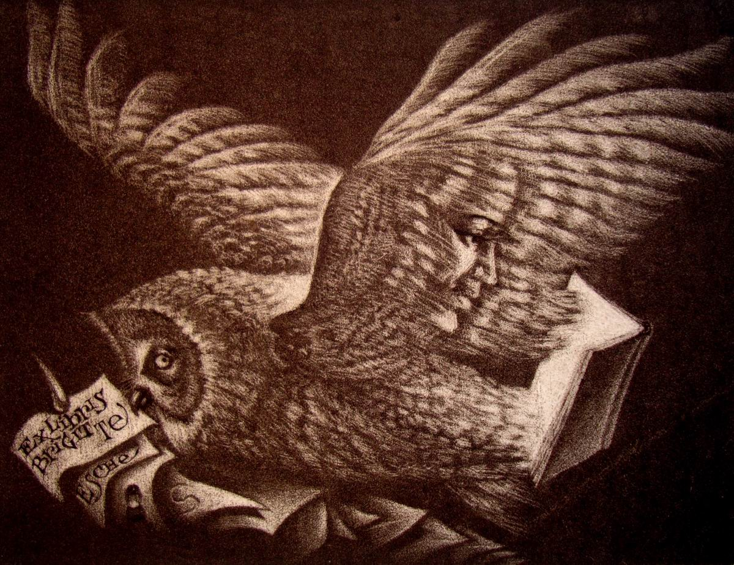
Figure 1 Bookplate – Brigitte Esche
(Source: Kocák, Peter. Ex libris. 2009.)

Text text text text text text text text text text text text text text text text text text text text text text text text text text text text text text text text text text text text text text text text text text text text text text text text text text text text text text text text text text text text text text text text text text text text text text text text text text text.
Text text text text text text text text text text text text text text text text text text text text text text text text text text text text text text text text text text text text text text text text text text text text text text text text text text text text text text text text text text text text text text text text text text text text text text text text text text text.

Text text text text text text text text text text text text text text text text text text text text text text text text text text text text text text text text text text text text text text text text text text text text text text text text text text text text text text text text text text text text text text text text text text text text text text text text text text text.

Table 1 Annual accruals
Year | 2001 | 2002 | 2003 | 2004 | 2005 | 2006 | 2007 | 2008 | 2009 | 2010 | 2011
Purchased | 1704 | 3392 | 2716 | 4022 | 3918 | 3202 | 2959 | 2925 | 2846 | 3637 | 3450
Printed compulsorily | 0 | 0 | 0 | 0 | 0 | 0 | 0 | 0 | 0 | 0 | 0
Gifts | 1551 | 967 | 1012 | 8421 | 1688 | 3029 | 2249 | 5907 | 2018 | 1724 | 1754
Exchanged | 30 | 54 | 12 | 23 | 11 | 61 | 18 | 12 | 44 | 75 | 95
Replaced | 107 | 0 | 0 | 0 | 0 | 0 | 0 | 0 | 0 | 0 | 0
Other | 0 | 127 | 899 | 528 | 187 | 382 | 332 | 0 | 1063 | 583 | 327
Total | 3392 | 4546 | 4639 | 12994 | 5804 | 6681 | 5558 | 8844 | 5971 | 6019 | 5626
(Source: own compilation)

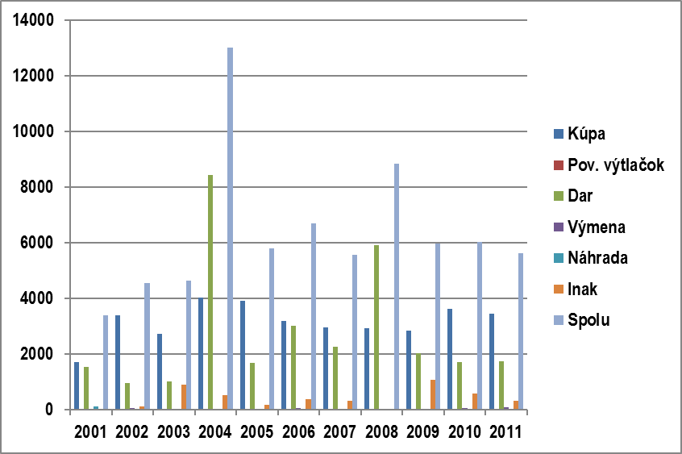
Graph 1 Annual accruals
(Source: own compilation)

Text text text text text text text text text text text text text text text text text text text text text text text text text text text text text text text text text text text text text text.
CONCLUSION
Text text text text text text text text text text text text text text text text text text text text text text text text text text text text text text text text text text text text text text text text text text text text text text text text text text text text text text text text text text text text text text text text text text text text text text text text text text text text text text text text text text text text text text text text text text text text text text text text text text text text text text text text text text text text text text text text text text text text text text text text text text text text text text text text text text text text text text text text text text text text text text text text text text text text text text text text text text text text text text text.
Text text text text text text text text text text text text text text text text text text text text text text text text text text text text text text text text text text text text text text text text text text text text text text text text text text text text text text text text text text text text text text text text text text text text text text text text text text text text text text text text text text text text text text text text text text text text text text text text text text text text text text text text text text text text text text text text text text text text text text text text text text text text text text text text text text text text text text text text text text text text text text text text text text text text text text text text text text text text text text text text text text text text text text text text text text text text text text text text text text text text text text text text text text text text text text text text text text text text text text text text text text text text text text text text text text text text text text text text text text text text text text.
Text text text text text text text text text text text text text text text text text text text text text text text text text text text text text text text text text text text text text text text text text text text text text text text text text text text text text text text text text text text text text text text text text text text text text text text text text text text text text text text text text text text text text text text text text text text text text text text text text text text text text text text text text text text text text text text text text text text text text text text text text text text text text text text text text text text text text text text text text text text text text text text text text text text text text text text text text text text text text text text.

The conclusion of the dissertation/thesis contains objective conclusions, a summarisation of the dissertation/thesis and the author's own insights or opinions with regard to the stated aims and any hypotheses of the dissertation/thesis. The conclusions must be consistent with the interpretation, arguments, considerations, description and reasoning in the body of the dissertation/thesis
SUMMARY
Text text text text text text text text text text text text text text text text text text text text text text text text text text text text text text text text text text text text text text text text text text text text text text text text text text text text text text text text text text text text text text text text text text text text text text text text text text text text text text text text text text text text text text text text text text text text text text text text text text text text text text text text text text text text text text text text text text text text text text text text text text text text text text text text text text text text text text text text text text text text text text text text text text text text text text text text text text text text text text text.
Text text text text text text text text text text text text text text text text text text text text text text text text text text text text text text text text text text text text text text text text text text text text text text text text text text text text text text text text text text text text text text text text text text text text text text text text text text text text text text text text text text text text text text text text text text text text text text text text text text text text text text text text text text text text text text text text text text text text text text text text text text text text text text text text text text text text text text text text text text text text text text text text text text text text text text text text text text text text text text text text text text text text text text text text text text text text text text text text text text text text text text text text text text text text text text text text text text text text text text text text text text text text text text text text text text text text text text text text text text text text text text.
Text text text text text text text text text text text text text text text text text text text text text text text text text text text text text text text text text text text text text text text text text text text text text text text text text text text text text text text text text text text text text text text text text text text text text text text text text text text text text text text text text text text text text text text text text text text text text text text text text text text text text text text text text text text text text text text text text text text text text text text text text text text text text text text text text.

Summary in the Slovak language is a compulsory part of the thesis, if it is written in a
foreign language. The length is at most 10% of the final thesis. The summary may also be
given in a language other than Slovak, if the supervisor deems it necessary

LIST OF BIBLIOGRAPHICAL REFERENCES

ANDREJČÍKOVÁ, Nadežda, 1999. Komunikácia a kooperácia IS pre knižnice: úvod do komunikačného protokolu Z39.50 [Communication and IT System Assistance for Libraries: Introduction to the Z39.50 Communication Protocol]. In: Bulletin Centra vedecko-technických informácií SR [Bulletin of the Slovak Scientific and Technical Information Centre]. Volume year 3, No 2, pp. 54-59. ISSN 1335-793X.
Anonymous, 2009. Dohovor o ochrane svetového kultúrneho a prírodného dedičstva [Convention Concerning Protection of the World Cultural and Natural Heritage] [online]. [cit. 15 July 2013]. Available at: http://www.enviroportal.sk/dohovory/dohovory-detail.php?dokument=154
BANÍK, Anton Augustín, 2010. Korešpondencia s Pavlom Horváthom [Correspondence with Pavol Horváth]. 2 pages. Manuscript. Methodological discussion from 1911. Location: Martin: Slovak National Library, Archive of Literature and Art. Location number A XC/ 4-1.
BAUMGARTNER, J. et al., 1998. Ochrana a udržiavanie genofondu zvierat, šľachtenie zvierat: výskumná správa [Protection and Maintenance of the Animal Gene Pool, Animal Breeding: a Research Report]. Nitra: VÚŽV [Slovak Research Institute for Animal Production].
GÁBRIŠ, T., 2005. Návrh obchodnoprávnej úpravy regnikolárnej deputácie in iudicis [Proposal for Legislation on the Parliamentary Preparatory Committee]. In: K. SCHELLE and L. VOJÁČEK, eds. Stát a právo v období absolutismu: sborník [The State and Law in the Period of Absolutism: an Anthology]. Brno: Masarykova univerzita [Masaryk University], p. 175.
HORVÁT, J. et al., 1999. Anatómia a biológia človeka [Human Anatomy and Biology]. 2nd Edition Bratislava: Obzor. ISBN 80-07-00031-5.
http://www.snk.sk/swift_data/source/NBU/Kniznica/11_12_2001/662.pdf
INFOS 2001: An Anthology from the 31st International Information Science Symposium, held from 2-5 April 2001 in Stará Lesná. 2001. Bratislava: Spolok slovenských knihovníkov [Association of Slovak Libraries]. ISBN 80-85165-84-8.
ISO 690: 2010, Information and documentation. Guidelines for bibliographic references and citations to information resources.
KOMOROVÁ, Klára, 2005. Najstaršie trnavské tlače v Slovenskej národnej knižnici v Martine [The Oldest Trnava Printing Press in the Slovak National Library in Martin]. In: Kniha 2005: zborník o problémoch a dejinách knižnej kultúry [The Book 2005: An Anthology of the Problems and History of Book Culture]. Martin: Slovenská národná knižnica [Slovak National Library], pp. 341-345. ISBN 80-89023-55-X.
KOVAČKA, M., ed., 2000. Bibliografický zborník 1992-93 [Bibliographical Anthology 1992-93]. Martin: Matica slovenská [Slovak Matica]. ISBN 80-7090-507-7.
KOVAČKA, Miloš and KUCIANOVÁ, Anna, 1998. 35. výročie ŠVK v Banskej Bystrici [35th Anniversary of the State Scientific Library in Banská Bystrica]. In: Banská Bystrica. Banská Bystrica: ŠVK [State Scientific Library], pp. 14-16.
KUCIANOVÁ, Anna, 2001. Významná personálna bibliografia [Significant Personal Bibliography]. In: Knižnica [Library] [online]. Volume year 2, No 11-12, p. 662 [cit. 15 June 2013]. ISSN 1336-0965. Available at:
KUCIANOVÁ, Anna, 2005b. Personálie v elektronickej súbežnej Slovenskej národnej bibliografii [Personal Data in the Contemporary Electronic Slovak National Bibliography]. In: Bibliografický zborník 2000-2001 [Bibliographical Anthology 1992-93] [online]. Martin: Slovenská národná knižnica [Slovak National Library], pp. 136-139 [cit. 24 September 2012]. Available from: http://www.snk.sk/nbuu/Zborník_2000_2001.pdf
MIKULÁŠIKOVÁ, M., 1999. Didaktické pomôcka pre praktickú výučbu na hodinách výtvarnej výchovy pre 2. stupeň základných škôl: diplomová práca. [Teaching Aid for Practical Instruction in Art Classes at Stage 2 Primary Education: A Master's Dissertation] Nitra: UKF [Constantine the Philosopher University].
OBERT, V., 2006. Návraty a odkazy [Memories and References]. Nitra: Univerzita Konštantína Filozofa [Constantine the Philosopher University]. ISBN 80-8094-046-0.
ROHOŇOVÁ, Ľudmila and GAŠPAROVÁ, Mária, 2006. Metodika popisu článkov vo formáte MARC 21 s interpretáciou pravidiel AACR: príručka používateľa: verzia V 2.1 [Methodology for Describing Articles in MARC 21 Format with Interpretation of the AACR Rules: A User Manual: Version V 2.1]. [online]. Martin: Slovenská národná knižnica [Slovak National Library] [cit. 24 January 2013]. ISBN 80-89023-69-X. Available at: http://www.snk.sk/nbuu/metodika_clanky_MARC21.pdf
STEINEROVÁ, J., 2000. Princípy formovania vzdelania v informačnej vede [Principles of Learning in Information Science]. In: Pedagogická revue [Pedagogical Review]. Volume year 2, No 3, pp. 8-16. ISSN 1335-1982.
STEINEROVÁ, Jela, 2000. Základy filozofie človeka v knižničnej a informačnej vede [Basic Human Philosophy in Library and Information Science]. In: Š. KIMLIČKA et al., eds. Knižničná a informačná veda na prahu informačnej spoločnosti [Library and Information Science on the Threshold of the Information Society]. Bratislava: Stimul, pp. 9-56. ISBN 80-88982-29-4.
TIMKO, J., SIEKEL, P. and TURŇA, J., 2004. Geneticky modifikované organizmy [Genetically Modified Organisms]. Bratislava: Veda. ISBN 80-224-0834-4.
BERTALANFFY, Ludwig von, 1969. General Systems Theory. New York: Braziller.
Source:
KIMLIČKA, Štefan, 2004. Informačné systémy 1 [Information Systems 1] [online]. Bratislava: Univerzita Komenského [Comenius University] [cit. 15 March 2012]. Available at: http://www.fphil.uniba.sk/kkvi

The length depends on the number of information sources used, which must tally with the citations used in the text. The items in the list are in alphabetical order according to author, followed by the year of issue of the document (the items are left aligned). This is followed, if applicable, by lower-case letters to distinguish between references to the same initial information and year of issue.

APPENDICES
Appendix A Appendix title Appendix title Appendix title Appendix title Appendix title Appendix title Appendix title Appendix title Appendix title
Appendix B Appendix title Appendix title Appendix title Appendix title Appendix title Appendix title Appendix title Appendix title Appendix title

Analytical sheet

Author: | Forename and surname (academic and scientific-pedagogical  degrees)
Title of thesis: | Title of thesis (must be identical with the title in the MAIS system)
Subtitle of thesis:
Language of thesis: | English
Type of thesis: | Dissertation
Acquired academic  degree: | Philosophiae doctor
Number of pages: | Total number of pages including appendices (e.g. 54 pages)
University: | University of Presov in Presov
Faculty: | Faculty of Management and Business
Department:
Field of study: | Economics and Management
Study programme: | Management
Town/city: | Presov
Supervisor:
Consultants:
Date of submission: | DD.MM.YYYY
Date of defence: | DD.MM.YYYY
Keywords in Slovak: | Keyword 1, Keyword 2, Keyword 3,  Keyword 4, etc.
Title of thesis in English: | Title
Subtitle of thesis in English:
Keywords in English: | Keyword 1, Keyword 2, Keyword 3, Keyword 4, etc.

The analysis page is the last page of the dissertation/thesis, is numbered and is included in the length of the dissertation/thesis.

In the case of doctoral theses, specify the type (rigorous, dissertation).
Select the relevant one.
Specify the date of submission of the dissertation thesis
4 Author’s handwritten signature (each hard copy of the project submitted must be signed).
Each language version of the abstract must be on a separate page.
Specify the total number of pages, including the appendices.
CEJPEK, Jiří. Dějiny knihoven a knihovnictví [A History of Libraries and Librarianship]. 2002.
KATUŠČÁK, Dušan. Informačná výchova. Terminologický a výkladový slovník [Information Education. A Specialist Dictionary]. 1998.
KURUCOVÁ, Lívia et al. Knižné kalendáre II [Almanacs II]. 2011.

