Trainee Program Information

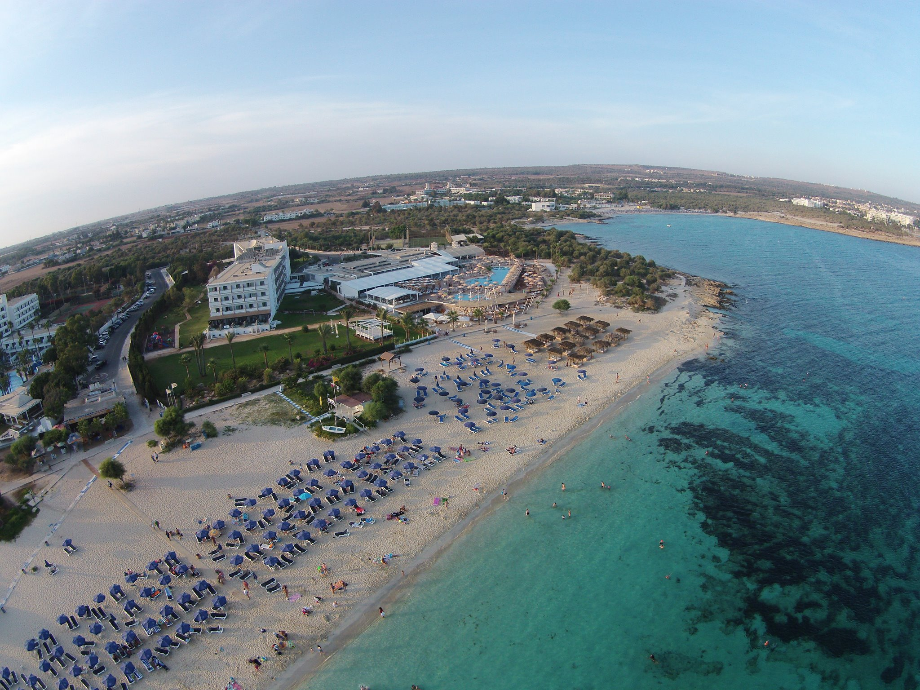

Cyprus

**Asterias Beach Hotel** is a four stars family owned and run Beach Hotel located in **Ayia Napa,** **Cyprus.** More specifically, it is located on Makronissos Bay West side of Ayia Napa close to Ayia Napa Waterpark and the new project of the Marina Ayia Napa. Our clientele is mainly Central European countries (Germany, Austria, Switzerland), UK & Russia markets.

Our Hotel has currently 245 Standard Rooms, 25 Deluxe Rooms and 5 Junior Suites, totalling to 275 Rooms.

It offers a variety of holiday packages regarding the terms of stay:

Bed & Breakfast, Half Board, Full Board, All Inclusive & Premium All Inclusive

Our Hotel level of services and standards are amongst the best in the island having achieved numerous awards and honours.

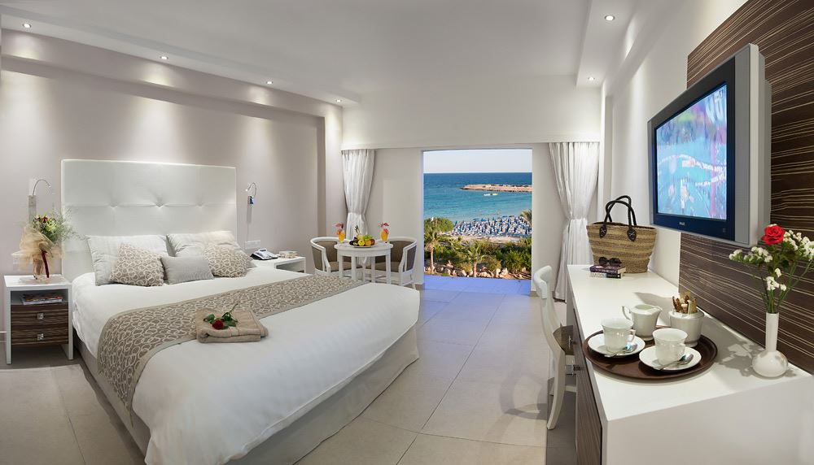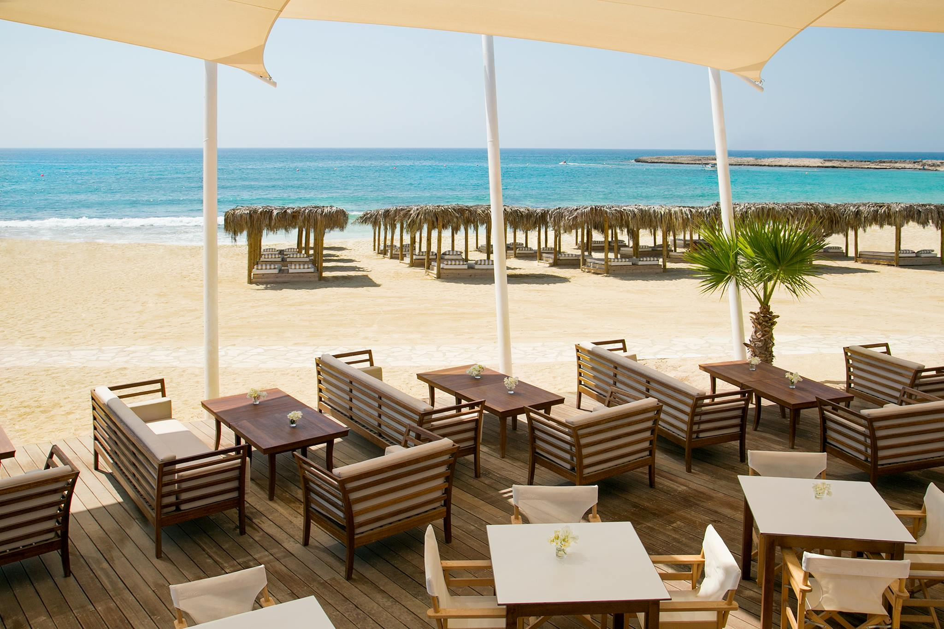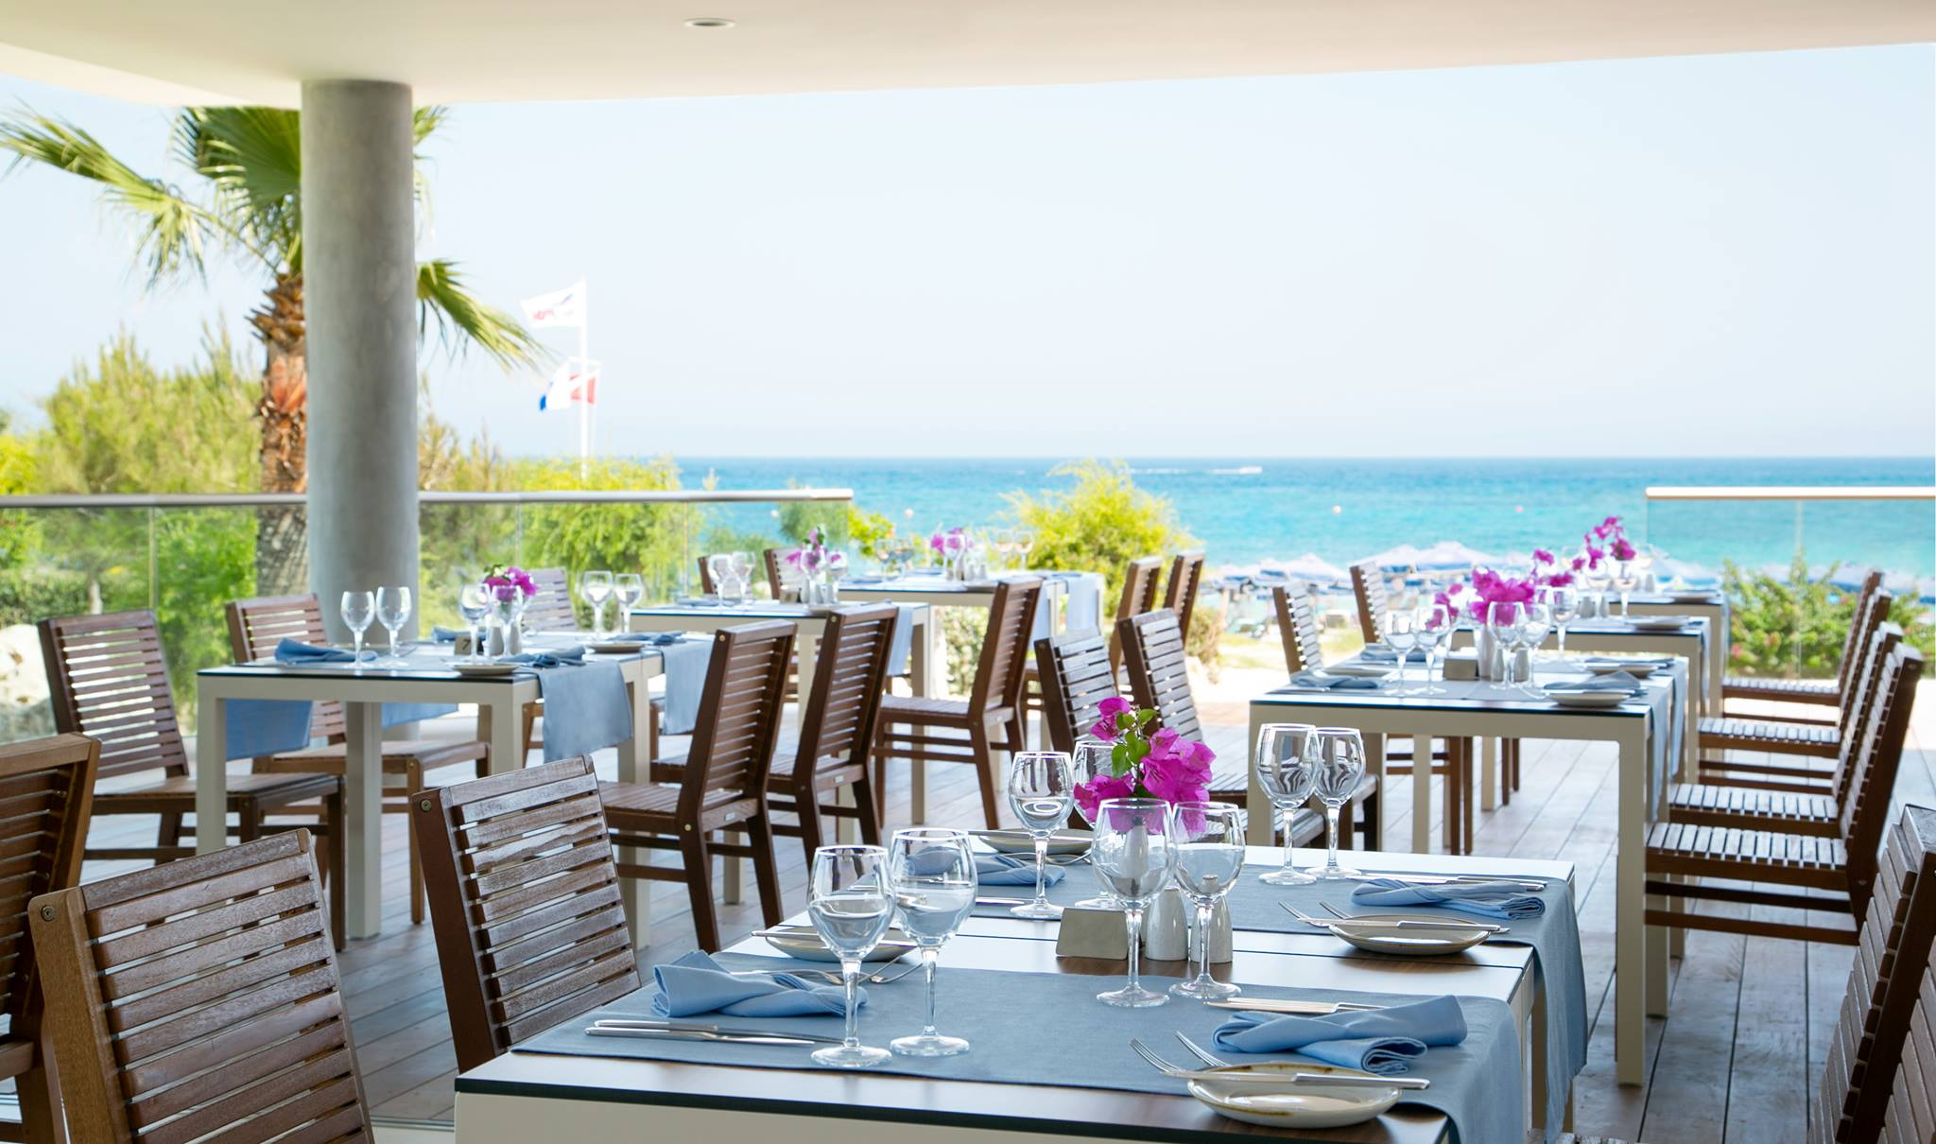

**Our Summer Trainee Program Details:**

* Trainees will work on a 6 days a week basis for 9hrs (including breaks for meals)
* Air tickets compensation up to €250.00
* Full Board for the duration of the stay (for all days)
* Accommodation included (free laundry service, electricity & water bills included as well)
* Salary €450.00 Net per month
* For additional information or any question please contact the international relations office at:
  + Mgr. Eva Benková, PhD.: [eva.benkova@unipo.sk](mailto:eva.benkova@unipo.sk)
  + Mgr. Zuzana Nováková: [zuzana.novakova@unipo.sk](mailto:zuzana.novakova@unipo.sk)