Sutledge Placement Consultants

Cala, Milton, Drumnadrochit, Inverness IV63 6UA
Tel: +44 (0)1456 450931
+420734836993
E-mails: georgestone654@gmail.com
jan.pokornik@gmail.com

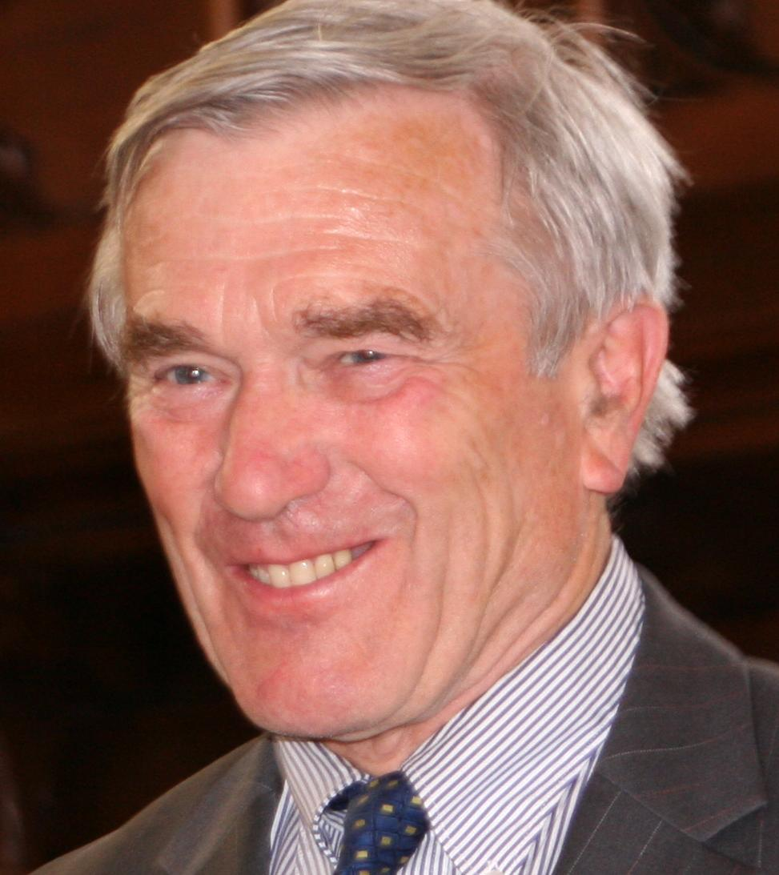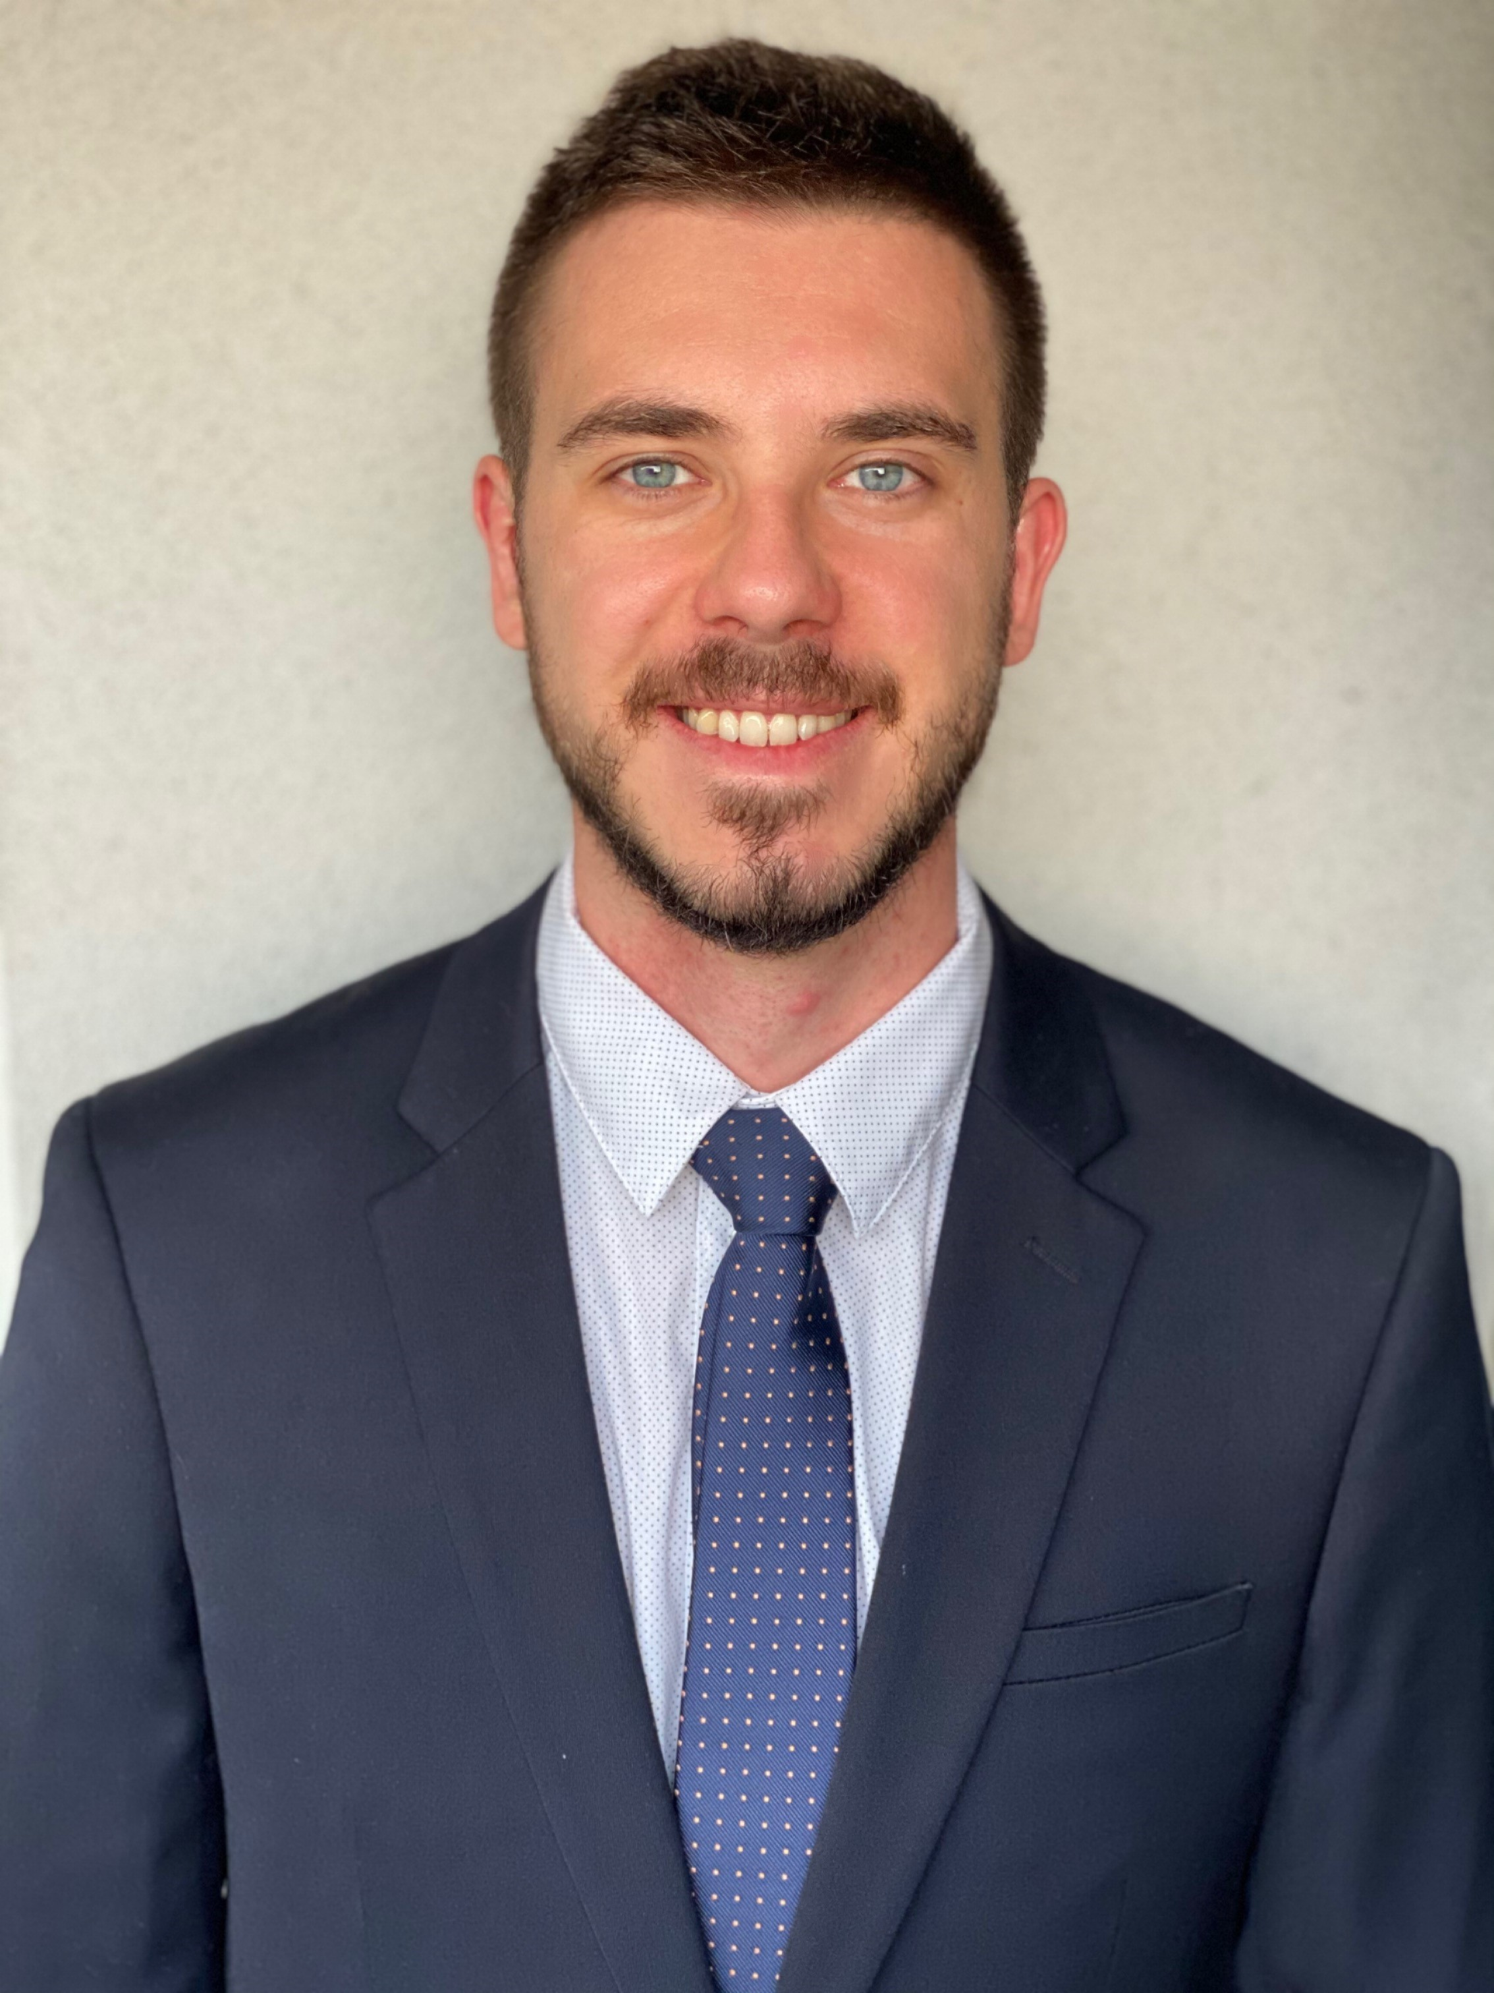

OPPORTUNITIES FOR STUDENTS/GRADUATES IN IRISH HOTELS
IN SUMMER 2022

Notes for Candidates

Who are Sutledge Placement Consultants? George and his wife Rene started a Hotels Programme in 2004 and have worked with Czech students on other Programmes since 1999. Jan was a part of the programme in Scotland for three years. Since 2021 he has become his partner who will take over the programme after George’s retirement.

Sutledge Placement Consultants operates a Programme to help Czech students and graduates to get work in Irish hotels. Because of Brexit we are no longer able to operate in Scotland. These notes are to tell you about the Programme for summer 2022.

Who are these Notes for?
These notes are for Czech and Slovak students, graduates, or other young people, who will be free to come to Ireland in 2022. Most hotels want people who can start in May and work for at least 4 months. It may also be possible to find work for people who can come around 20-30 June for 3 months until late September, but this is less easy. If you can stay until 31 October, that is always interesting to hotels.

Why should you come?
- You will be able to save money and bring home at least 300 Euros for each week of work.
- You will have the opportunity to improve your English, because English is the language in Ireland.
- You will get useful experience and learn valuable skills, and make new friends.

Why Ireland?
The Republic of Ireland is a beautiful country. It is a member of the European Union and so Czechs and Slovaks can work there with no formalities. The language of most people is English. 2022 will be second year that this Programme will operate in Ireland, after 17 years of operating with Scottish hotels.

What work will you do?
Most people can expect to do a mixture of housekeeping (which means room cleaning) and restaurant work. In some hotels you may be asked to do simple food preparation in the kitchen. If you have good skills as a cook, there may be work for you as an assistant cook.

Where will you live?
We work only with hotels which provide accommodation for you.

How will you be recruited by a hotel?
We shall ask you for information about yourself and pass it on to the hotels that we are in contact with. Some hotels will want to interview you by telephone. Other hotels will choose you from your written information. If you are offered a job, we hope you will accept it, but I allow you to say “No thank you” to an offer if you wish. It may be possible for you to get work with a particular friend. Generally, it is better to be at a hotel with no more than one friend.

Some people will get job offers very quickly; most will have them by 31 March and some will still be waiting until perhaps 15 May. Because of the uncertainty of the Coronavirus pandemic, hotels may have to cancel their job offers to you.

How do you get to Ireland?
You will need to make your own arrangements and pay for your air ticket. We will offer lots of advice. You will probably have to pay between 60 Euros and 100 Euros for a one-way journey. We will give you detailed advice about travelling in Ireland.

What about UK Government regulations?
We will help you with Social Insurance and Income Tax matters and similar things. We are here to support you and to do our best to make it a happy summer for you.

Do you have to pay us?
Yes, we ask everyone to pay a fee of 200 Euros within 2 months of starting work.

What should you do now?
Send us a completed Application Form (see end pages of these Notes) please, together with a nice photo showing you smiling. Good photos are asked for by most hotels – they are very important. You should make sure you are neat and smartly dressed with tidy hair and (for boys) have shaved recently. Your photo should show your head and shoulders. The background should be plain. "Selfie" photos are usually NOT suitable because they distort the dimensions of your head and shoulders.

We shall be in the Czech Republic and Slovakia again as soon as the pandemic allows us. If possible, we should like to meet you then. However, we may also contact you to arrange a time when we can interview you by telephone, or by Zoom.

George Stone, Jan Pokorník
July 2021

Sutledge Placement Consultants

Cala, Milton, Drumnadrochit, Inverness IV63 6UA
Tel: +44 (0)1456 450931
+420734836993
E-mails: georgestone654@gmail.com
jan.pokornik@gmail.com

APPLICATION FORM FOR HOTEL WORK IN IRELAND – 2022

Name (first name) (surname) Male / Female

Date of Birth

Home Address

Email Address

Telephone number (mobile)

What kind of work do you hope to get? Please underline your choices.

- Waiter/waitress

- Housekeeping (room cleaning/kitchen work)

- A mixture of both (waiter/waitress and housekeeping)

- Kitchen work (meal preparation)

- Kitchen work (cleaning and simple food preparation)

Dates available for work (start and finish: please show date and month, and give a minimum of 3 months)

What are your plans after summer 2021?

How good is your English language? Please underline your answer

- I can understand a simple conversation but cannot speak much;

- I can hold simple conversations;

- I can understand and speak fluently;

- I am very confident and fluent.

Are you willing to have a telephone interview with a hotel manager? Yes / No

Where are you (or were you) a student? What is your degree course, and what year are you in now?

Please write about any experience you have had in hotel / restaurant / shop work, or any long visits to or work in English-speaking countries. Also, write about any special skills you have in bar work, in a restaurant or in a restaurant/hotel kitchen.

Who told you about this Programme in Ireland? (A name would be helpful.)

How is your health? Excellent / Quite good / Poor

Are you a smoker? Yes / No

Do you have a driving licence? Yes / No

Please tell me the name of any friend you would like to work with.

Please attach your photo to this form.

