DECREE No. 614/2002 of Law Code
of Ministry of Education of the Slovak Republic
of 27 September 2002
on the credit system of study

The Ministry of Education of the Slovak Republic (hereinafter referred to as the “Ministry“) according to Section 20 Clause 1 Letter e), Section 62 Clause 4 and Section 68 Clause 4 of the Act No. 131/2002 of the Law Code on Higher Education and on the Change and Supplement to Some Acts (hereinafter referred to as the “Act”) sets out:

Section 1

Basic provisions

The present Decree specifies the structure of information on possibilities of study in a higher education institution, sets out general guidelines for introduction and application of the credit system of study and defines data to be included in the Diploma Supplement.

Section 2
The structure of information on possibilities of study in a higher education institution

(1) Information on possibilities of study in a higher education institution [Section 20 Clause 1 Letter e) of the Act] shall contain, in particular
- name and seat of the higher education institution, information on its organization structure, names of coordinators (Section 75 Clause 11 of the Act), information on organization of academic year, information on the mode of application for the study and the mode of matriculation,
- orientation information on residence registration with the police, on possibilities of accommodation, on health insurance, and on the provision of healthcare, on libraries, on possibilities of leisure time spending and on costs of the stay and living in the Slovak Republic,
- general characteristics of study programmes offered,
- detailed information on study programmes offered, including information sheets on course units,
- information on possibilities of obtaining academic degrees and acquiring qualification,
- information on study-related expenses.

(2) The information packages shall be prepared by the higher education institution in the official language and English language.

Section 3
Study programme units and subjects

(1) The study programme shall be divided into subjects (hereinafter referred to as “subject“). The subject is constituted of a study programme unit (Section 51 Clause 2 of the Act) or a group of study programme units oriented at provision of education in the given area (for example, lecture and the corresponding exercise).

(2) The basic data on the subject are the data according to table indicated in Annex 1.

(3) The subjects included in the study programme shall be divided according to their obligation to be undertaken, as follows:
- compulsory – their successful completing is a prerequisite of successful completion of a part of the study or the entire study programme,
- compulsorily optional – the successful completion of a part of study or the entire study programme is conditional on successful completing a specified number of subjects according to student’s choice in the framework as set out by the study programme,
- selective – the other subjects, which the student can choose from to complete his/her study course and thus to obtain sufficient number of credits in the given part of study (Section 51, Clause 4 Letter i) of the Act),

(4) The subjects included in the study programme shall be divided according to being connected to other subjects, as follows:
- the subjects conditional on successful completion of other subjects; registration for such a subject is conditional on the successful completing of another subject (conditioning subject) or other subjects,
- the subjects without any connection to other subjects; registration for such a subject is not conditional on completing another subject.

(5) Final thesis is considered as a subject.

(6) State examination (Section 63 Clause 1 of the Act) is not considered as a subject.

Section 4
Credits, their accumulation and transfer

(1) Any subject to be assessed upon completing shall be assigned a number of credits in the study programme, which the student shall receive upon its successful completion. Number of credits assigned to the subject shall correspond to number of credits assigned to the study programme units (Section 62 Clause 2 of the Act) constituting a subject (Section 3, Clause 1), and shall express the amount of work required for its successful completion.

(2) A student may receive credits for the subject only once during his/her study.

(3) The accumulation of credits shall mean calculating credits received for successful completion of subjects at the time in which the student was enrolled into the study course of one study programme. The credits calculated are those received
- within the framework of pursuing the study programme in case of its due completion (Section 65 of the Act),
- within the framework of a period of study completed in different faculty of the higher education institution,
- within the framework of a period of study completed in different higher education institution in the Slovak Republic or a higher education institution abroad, being formally provided for with the credit transfer requirements according to Section 7.

Section 5
Registration for and completion of subjects

(1) By the registration for the subjects the student shall determine which part of duties prescribed by the study programme he/she wants to complete in the next period of study to which the registration is related (trimester, semester or academic year).

(2) The student shall register for the subjects in such a way as to accumulate sufficient number of credits required for their successful completion in the given period that will allow him/her to continue in his/her studies.

(3) The student may repeatedly register during his/her study for the compulsory subject, which he/she failed to pass. After the second unsuccessful attempt to complete the compulsory subject the student shall be dismissed from the study (Section 66 Clause 1 Letter c) of the Act).

(4) The student may repeatedly register during his/her study for the compulsorily optional subject, which he/she failed to pass, or he/she may register for another compulsorily optional subject instead. After the second unsuccessful attempt to complete the compulsorily optional subject the student shall be dismissed from the study (Section 66, Clause 1, Letter c) of the Act).

(5) The student may repeatedly register during his/her study for the selective subject, which he/she failed to pass, or he/she may register for another selective subject instead. If the student accumulates sufficient number of credits he/she need not register for any selective subject.

(6) The higher education institution or a faculty, if the study programme is performed at the faculty, shall determine a recommended study plan for each study programme. The recommended study plan is compiled in such a way as to enable the student to meet by its completing all conditions for successful finishing his/her study within the framework of the standard length of study corresponding to the study programme (Section 51, Clause 4, Letter h) of this Act).

Section 6
Assessment of study results

  - The assessment of the student’s study results within the framework of the subject course shall be carried out, particularly, through
- continuous control of study results during taught courses of the given period of study (test questions, tests, assignments for independent work, coursework, seminar papers, etc.),
- examination for the given period of study.

  - The completion of a subject shall be assessed by grading scales. A grade expresses the quality of knowledge or skills achieved in agreement with the subject aim, as indicated in the information sheet of the subject.

  - Grading shall be carried out according to grading scale made up of six grades:
- A – excellent (outstanding performance) = 1
- B – very good (above the average performance) = 1,5
- C – good (average performance) = 2
- D – satisfactory (fair performance) = 2,5
- E – sufficient (performance meets the minimum criteria) = 3
- FX – fail (performance does not meet even the minimum criteria) = 4

(4) If a higher education institution or faculty uses its own grading system, it is obliged to define the transfer of its institutional grading system to the grading scale under Clause 3.

(5) The student shall obtain credits for the subject, if his/her results have been assessed by some of the grades in the grading scale from A to E.

(6) A higher education institution or faculty, if the study programme is performed in the faculty, may decide at selected subjects that they will not be assessed by grades and it may set different criteria for their successful completing as a condition for obtaining credits.

(7) For evaluation of overall study results of the student in the given period a course weighted average shall be used. The calculation shall be done in such a way that the products of number of credits and numerical assessment shall be summed up in the period assessed according to Clause 3 for all subjects registered by the student and the result shall be divided by total number of credits obtained by the student for the given period. For the subjects, which the student registered and did not complete, grade 4 shall be counted in the course weighted average. The subjects, which are not assessed by grades (Clause 6), shall not be included in calculation of the student’s course weighted average.

Section 7
Formal requirements of credit transfer

  - Completion of a period of study at another higher education institution shall be formally conditioned by
- student exchange application form the pattern of which is appended in Annex 2,
- study agreement the pattern of which is appended in Annex 3,
- transcript of records the pattern of which is appended in Annex 4.

(2) The study contract shall be concluded between the student, the delegating higher education institution and the receiving higher education institution before entry of the student into the receiving higher education institution.

(3) The subjects completed in the receiving higher education institution shall be recognized to the student by the delegating higher education institution on the basis of transcript of records prepared for the student by the receiving higher education institution upon termination of his/her study. The transcript of records shall become a part of the student’s personal study documentation kept by the higher education institution.

Section 8
Diploma Supplement

(1) Pattern of the Diploma Supplement is shown in Annex 5.

(2) A constituent part of the Diploma Supplement shall be information on the system of higher education in the Slovak Republic to be prepared and released by the Ministry.

Section 9
Use of the credit system in study programmes of the third level

The use of the credit system in the study programmes of the third level shall be referred to in the provisions of this Decree appropriately.

Section 10
Efficacy

This Decree shall come into force on 1st November 2002.

Peter Ponický, signed in his own hand

ANNEX TO DECREE NO. 614/2002 LAW CODE
P A T T E R N
Name of higher education institution, name of faculty:

Information sheet on course unit
Code: | Name:
Field of study:
Guaranteed by: |  | Delivered by:
Study period of the course unit: | Form of instruction (lecture, seminar, laboratory course...):  Recommended scope of teaching (in hrs):  Weekly: For the period of study: |  |  | Number of credits:
Conditioning course units:
Mode of assessment and completing the course unit:

Continual assessment (e.g., test, independent work ...):

Final evaluation (e.g., examination, final thesis...):
Aim of the course unit:
Brief course unit programme:
Literature:
Language in which the course unit is held: |  |  | Signature of the guarantor and date of last edition of the sheet:

ANNEX 2 TO DECREE 614/2002 OF LAW CODE
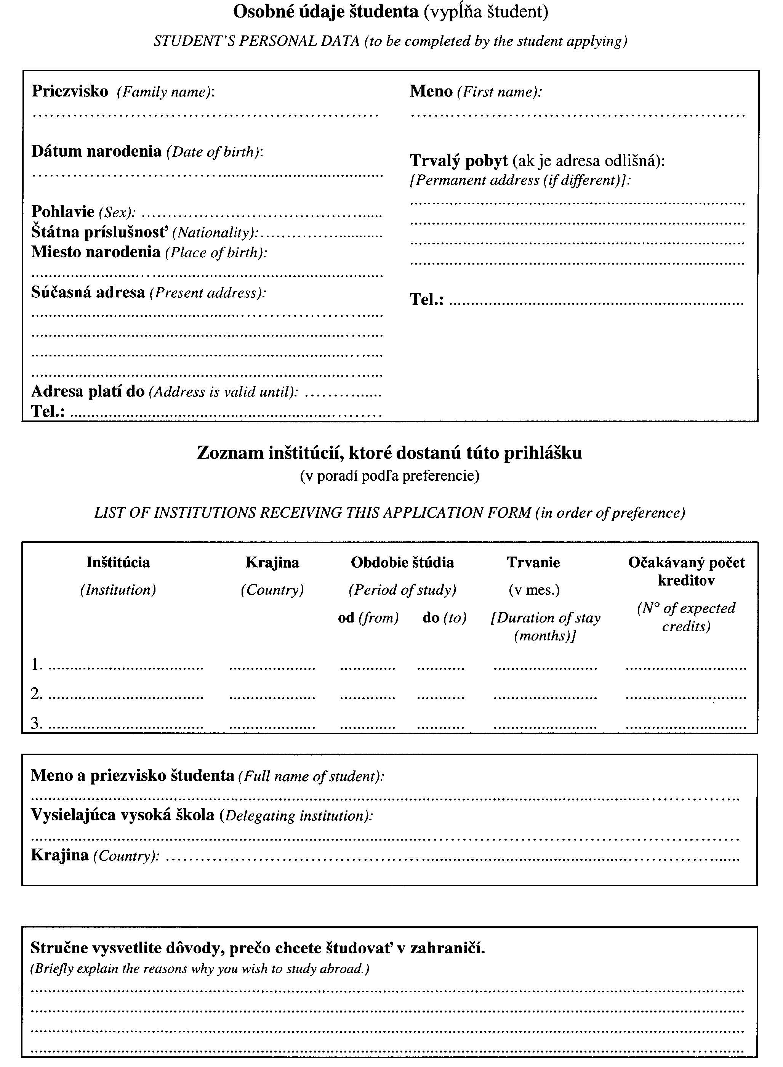
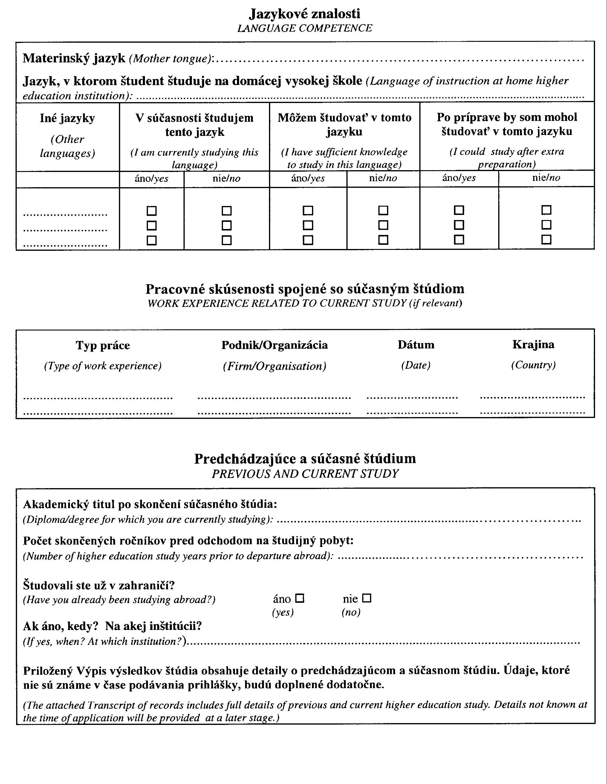
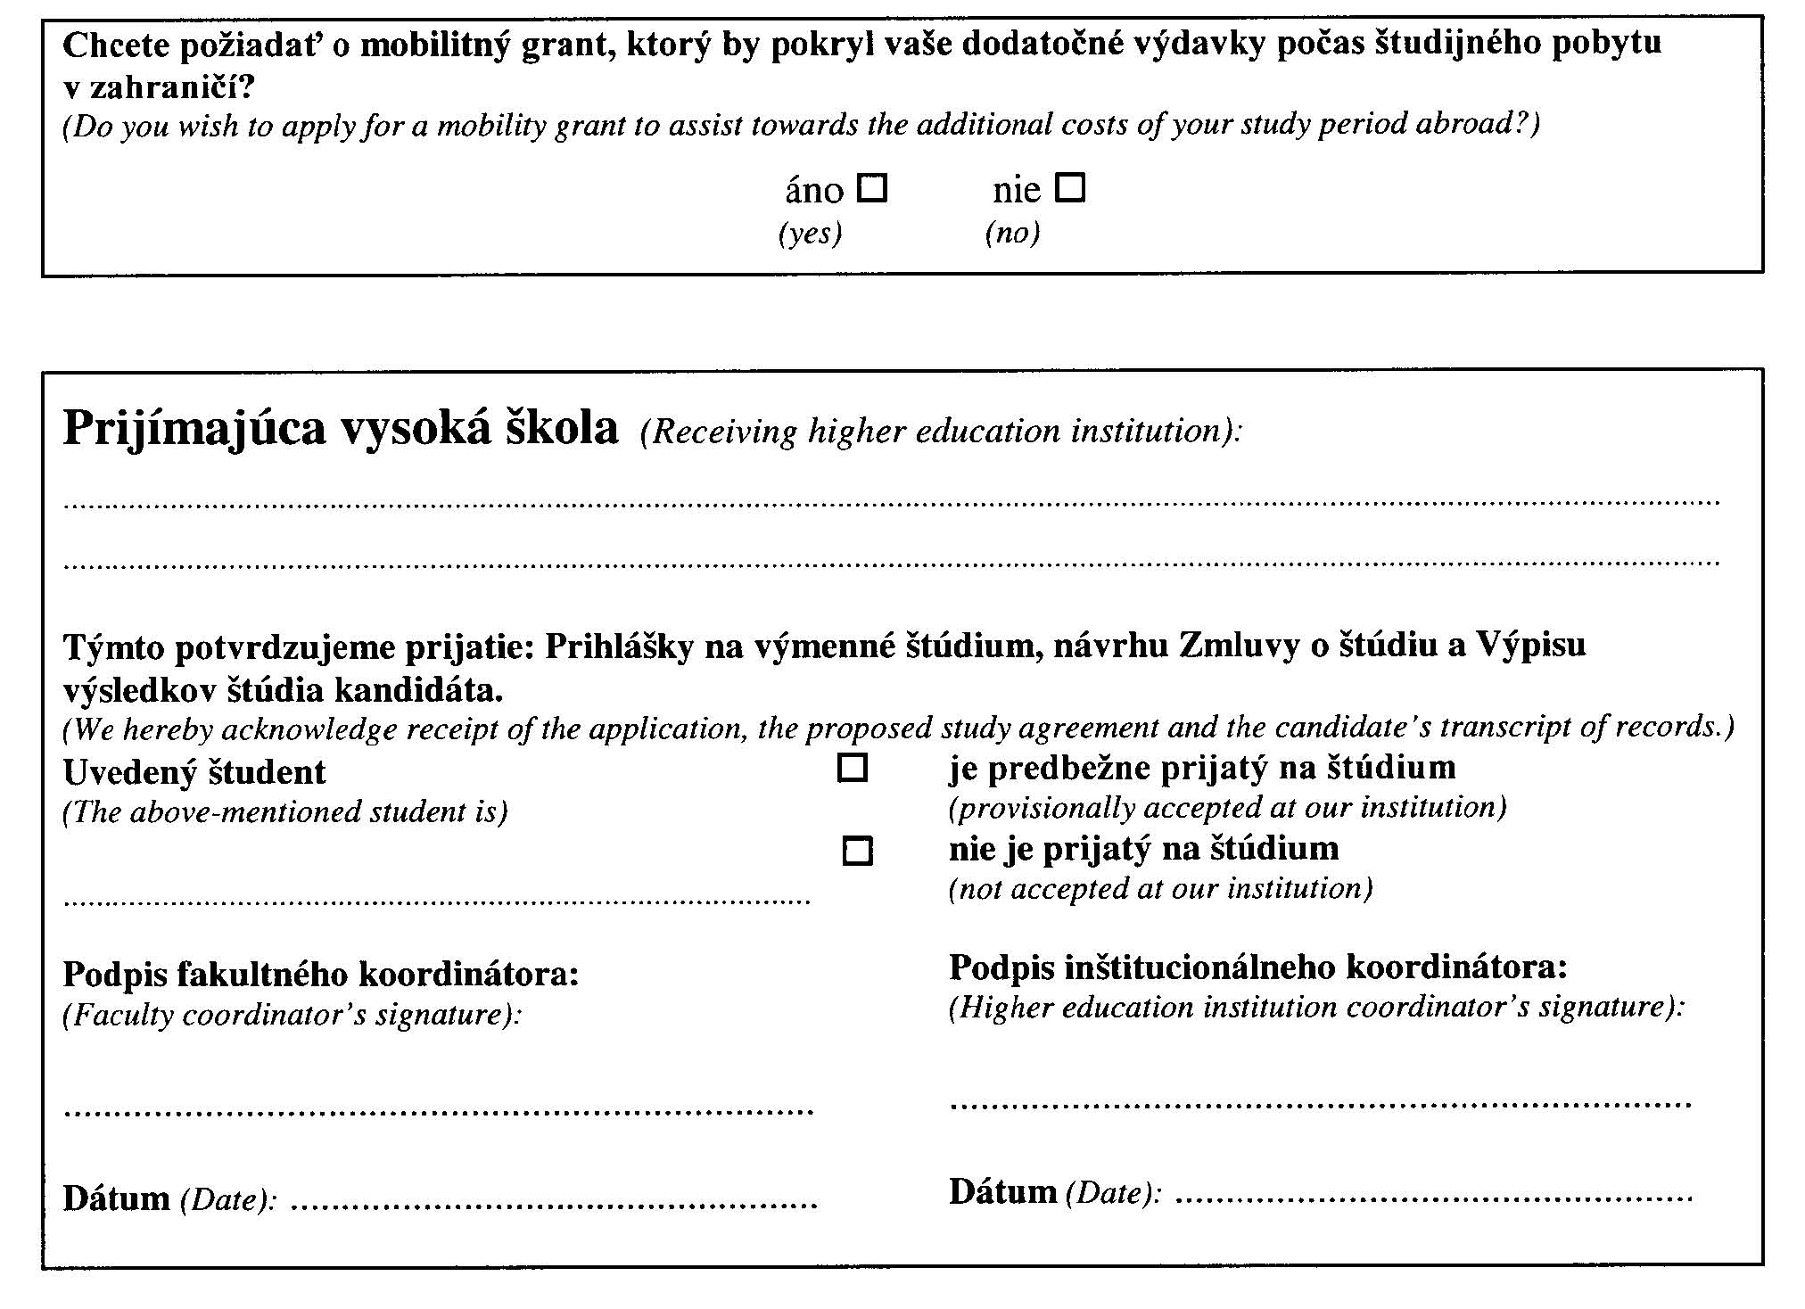

ANNEX 3 TO DECREE 614/2002 OF LAW CODE
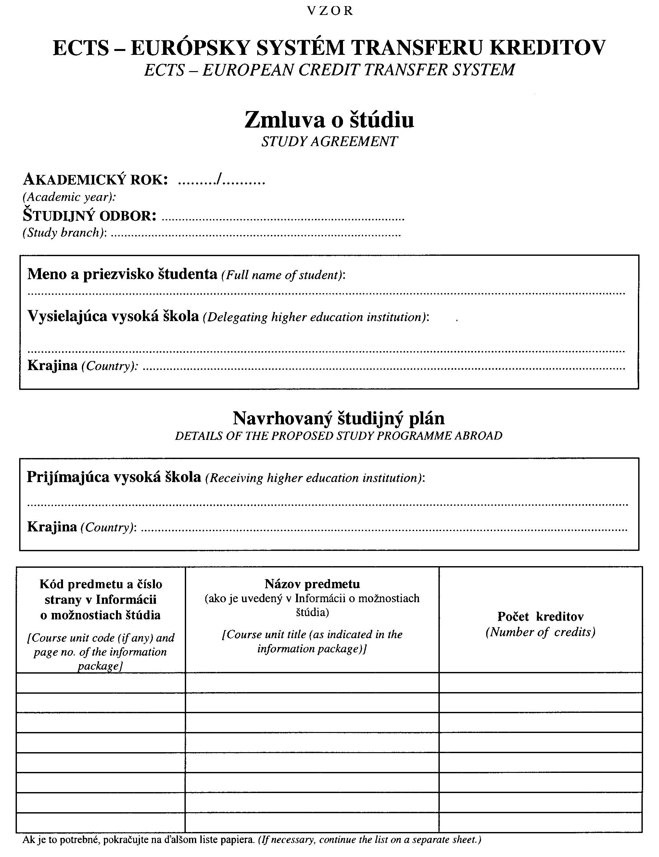
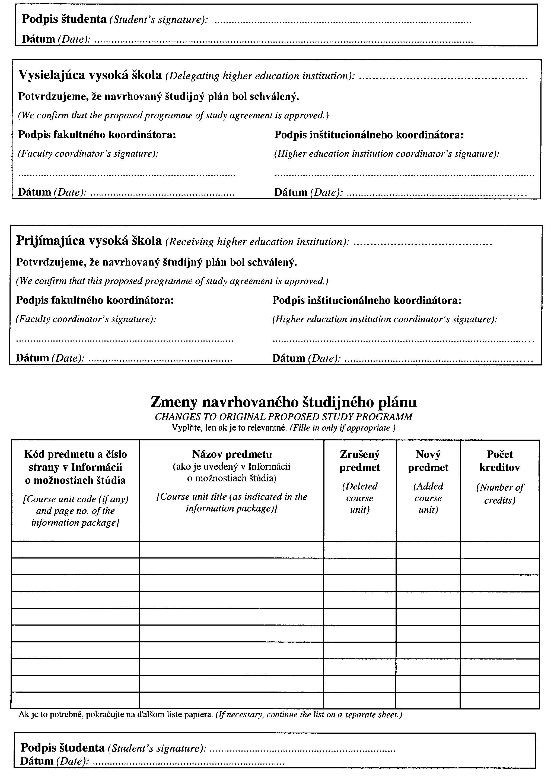
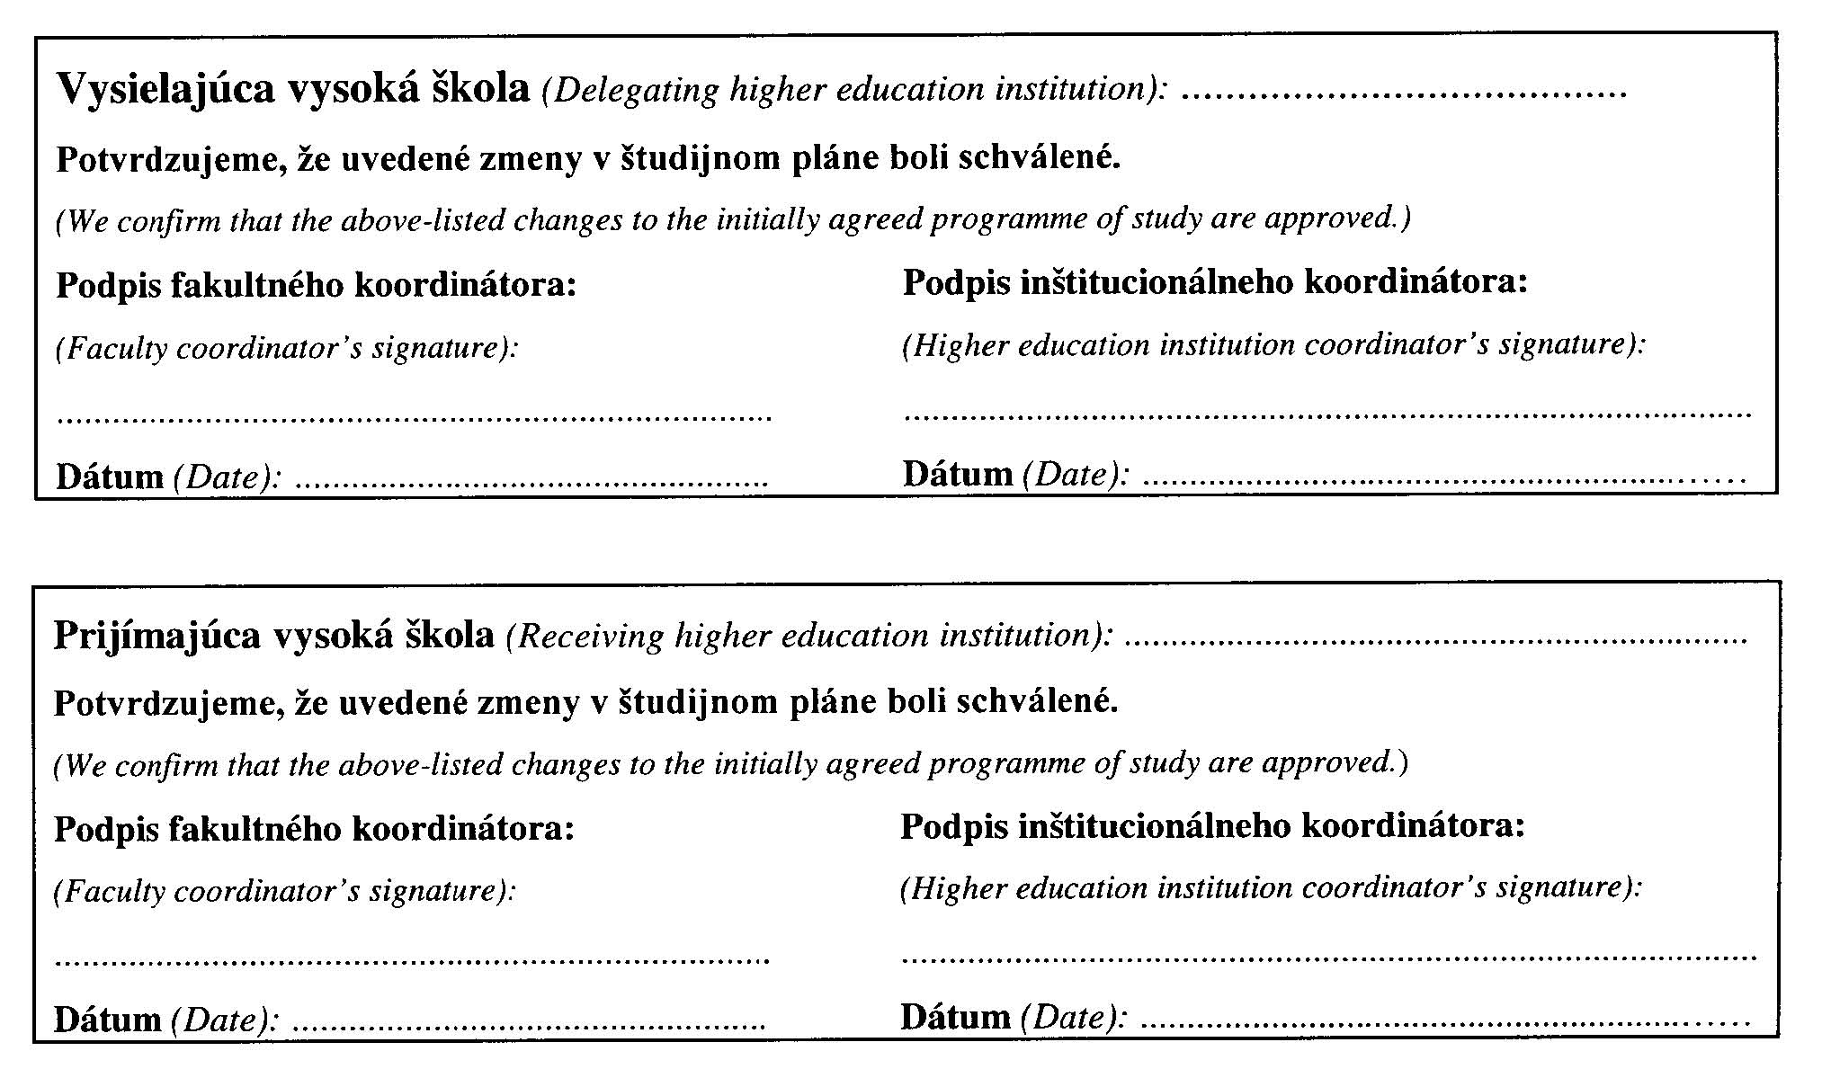

ANNEX 4 TO DECREE NO. 614/2002 OF LAW CODE
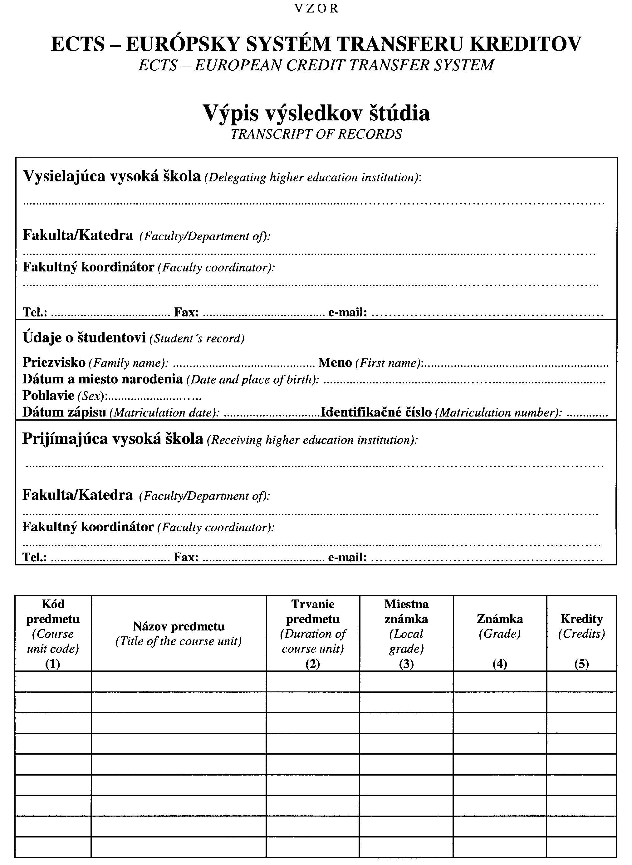
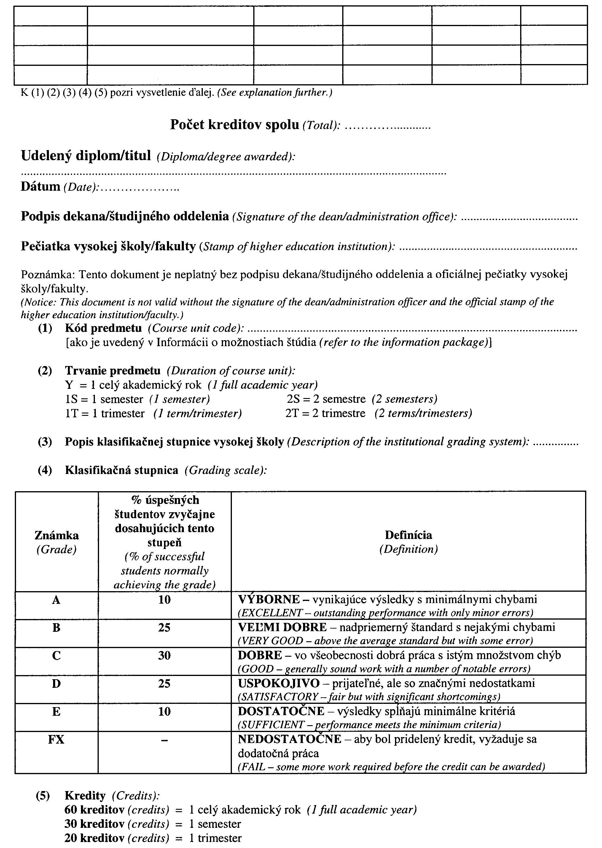
ANNEX 5 TO DECREE
NO. 614/2002 OF LAW CODE
P A T T E R N

DIPLOMA SUPPLEMENT
1. INFORMATION ON GRADUATE OF THE HIGHER EDUCATION INSTITUTION
  - Family name(s): .................................................................................................................................................................
1.2. First name(s):.......................................................................................................................................................................
1.3. Date of birth (day, month, year):..........................................................................................................................................
1.4. Student identification number or code: ................................................................................................................................
2. INFORMATION ON RECEIVED EDUCATION

2.1. Title of diploma received upon completing the study and the academic degree awarded (in Slovak language): ………

2.2. Field of study pursued:.........................................................................................................................................................
2.3. Name and status of awarding institution (in Slovak language):...........................................................................................
2.4. Name and status of institution (if different from 2.3.) administering studies (in Slovak language): ................................
2.5. Language(s) of instruction/examination: .............................................................................................................................
3. INFORMATION ON THE LEVEL OF HIGHER EDUCATION

3.1. Level of higher education:....................................................................................................................................................
3.2. Standard length of programme:............................................................................................................................................
3.3. Admission requirements:......................................................................................................................................................
4. INFORMATION ON THE CONTENTS AND RESULTS GAINED

4.1. Form of study: ...................................................................................................................................................................
4.2. Data on study programme:.................................................................................................................................................
4.3. List of course units pursued and grades/credits obtained
(according to transcript on records): .................................................................................................................................
4.4. Grading scale:....................................................................................................................................................................
4.5. Overall classification (in Slovak language):.....................................................................................................................
5. INFORMATION ON THE FUNCTION OF EDUCATION

5.1. Access to further study:......................................................................................................................................................
5.2. Professional status in the system of professional qualifications (if applicable):..................................................................
6. ADDITIONAL INFORMATION

6.1. Additional information:......................................................................................................................................................
6.2. Further information sources:...............................................................................................................................................
7. CERTIFICATION OF THE SUPPLEMENT

7.1. Date:.....................................................................................................................................................................................
7.2. Signature:.........................................................................................................................................................
7.3. Capacity:..............................................................................................................................................................................
7.4. Official stamp or seal:...........................................................................................................................................................

8. INFORMATION ON THE HIGHER EDUCATION SYSTEM IN THE SLOVAK REPUBLIC

